Rendering Fractals Using the PYNQ Framework on an FPGA

Filip Lejhanec

Supervisor: Dr Louise Helen Crockett

Second Assessor: Dr Alexandra Coddington

27th March 2019

# Abstract

Fractal rendering represents a computationally heavy task that requires a lot of raw performance, if satisfying results are to be achieved. The Python productivity for Zynq (PYNQ) project from Xilinx makes it easier to design embedded systems with Xilinx Zynq Systems on Chips, which can be used to perform hardware acceleration of algorithms by processing them on an FPGA programmed with a custom designed digital circuit. Based on a review of various fractals, a Mandelbrot set was selected as a suitable candidate whose rendering should be implemented on an FPGA.

After developing a software solution in Python as a starting point, an intellectual property (IP) block, capable of generating a Mandelbrot fractal images based on given input, was designed using high-level synthesis (HLS) and integrated into an overlay block design used to program the FPGA. The overlay further included a video pipeline with HDMI output capabilities. Custom drivers were designed to facilitate communication between Python code and the FPGA. After undergoing a complex optimisation, the IP achieved more than 2000 times higher performance than the software solution. Additionally, a desktop application with a standalone OpenCL Mandelbrot renderer was developed in Python, which allows a user to connect to the FPGA through an SSH connection and provides an interactive graphical user interface for fractal exploration.

# Table of Contents

Abstract 2

Table of Contents 3

1 Introduction 8

2 Aims and Objectives 9

3 Research 10

3.1 PYNQ-Z1 10

Figure 1: PYNQ-Z1 board [5] 10

3.2 Fractals 11

3.2.1 Sierpinski Triangle 11

Figure 2: Sierpinski Triangle [8] 11

3.2.2 Iterated Function System 12

Figure 3: Barnsley's fern [10] 12

3.2.3 Mandelbrot Set 12

Figure 4: Mandelbrot set [12] 13

3.2.4 Julia Set 13

Figure 5: Julia set [13] 14

3.2.5 Choosing the Right Fractal 14

4 Software Implementation 15

4.1 Programming Language 15

4.2 Architecture 15

4.2.1 Model 15

Code listing 1: Model implementation in file Mandelbrot_SW.py 16

4.2.2 View 17

Code listing 2: View implementation in file MatplotlibView.py 17

4.2.3 Controller 17

Code listing 3: Controller implementation in file Controller.py 18

4.3 Results 18

Code listing 4: Example execution script 18

Figure 6: Resulting plot 19

Code listing 5: Jupyter notebook execution script on PYNQ-Z1 19

5 Hardware Implementation 20

5.1 Project Structure 21

5.2 Single Pixel Calculation 22

5.2.1 IP Design in Vivado HLS 22

Code listing 6: Config.h 23

Code listing 7: Mandelbrot.h 23

Code listing 8: Mandelbrot.cpp 24

Code listing 9: Mandelbrot_tb.cpp 25

5.2.2 Overlay Design in Vivado IP Integrator 25

Table 1: Resource utilization 25

Figure 7: Overlay design in Vivado IP Integrator 26

5.2.3 Python Drivers and Jupyter Notebook Design 27

Code listing 10: Hardware model implementation in file Mandelbrot_HW.py 28

Code listing 11: Jupyter notebook execution script on PYNQ-Z1 29

5.2.4 Results 29

5.3 Full Image Calculation 29

5.3.1 IP Design in Vivado HLS 30

Code listing 12: Mandelbrot.h 31

Code listing 13: Mandelbrot.cpp 32

Code listing 14: Mandelbrot_tb.cpp 33

Figure 8: Resulting fractal image 33

5.3.2 Overlay Design in Vivado IP Integrator 34

Table 2: AXI Video Direct Memory Access IP properties 35

Figure 9: Overlay design in Vivado IP Integrator 36

5.3.3 Python Drivers and Jupyter Notebook Design 37

Code listing 15: Content of cell 1 in Mandelbrot.ipynb Jupyter notebook file 37

Code listing 16: Content of cell 2 in Mandelbrot.ipynb Jupyter notebook file 38

Code listing 17: Content of cell 3 in Mandelbrot.ipynb Jupyter notebook file 39

Code listing 18: Content of cell 4 in Mandelbrot.ipynb Jupyter notebook file 39

Code listing 19: Content of cell 5 in Mandelbrot.ipynb Jupyter notebook file 40

Code listing 20: Content of cell 6 in Mandelbrot.ipynb Jupyter notebook file 40

5.3.4 Results 40

5.4 Optimised IP Design 40

5.4.1 Pipelining the Execution 41

Table 3: Values stored for each pixel needed to calculate the next iteration 42

5.4.2 Unrolling Loops and Parallelisation 42

5.4.3 Fixed-Point vs. Floating-Point and Arbitrary Precision Data Types 44

Code listing 21: Fixed-point data type definition 44

Table 4: Resource usage for fixes-point and floating-point implementations 45

Table 5: Render configurations for precision comparison 46

Figure 10: First render for the fixed-point implementation 47

Figure 11: First render for the floating-point implementation 47

Figure 12: Second render for the fixed-point implementation 48

Figure 13: Second render for the floating-point implementation 48

5.4.4 Low-Level Optimisations 49

5.4.5 Resulting Solution 50

Code listing 22: Content of Mandelbrot.h file after optimisation 50

Code listing 23: Content of Mandelbrot.cpp file after optimisation 50

5.4.6 Results 53

5.5 Performance Comparison 53

Figure 14: Graph comparing render times of different implementations 53

6 Interactive Application 54

6.1 Adjustable Colours 55

6.2 HDMI Output 56

6.3 Drivers and Python Scripts on the PYNQ-Z1 58

6.4 C++ Accelerators 58

6.5 Desktop Graphical User Interface 60

6.6 Results 62

Figure 15: Initial state of the GUI 63

Figure 16: Example of a GUI state after user interaction 64

7 Summary of Results 65

8 Discussion 66

9 Conclusion 68

Appendices 69

Appendix A Config.h 69

Appendix B Mandelbrot.h 70

Appendix C Mandelbrot.cpp 71

Appendix D Top-level overlay design 75

Appendix E Block design of the video hierarchy 76

Appendix F Block design of the hdmi_out hierarchy 77

Appendix G Block design of the frontend hierarchy 78

Appendix H Constraints file for HDMI outputs 79

Appendix I Mandelbrot.py 80

Appendix J AxiVDMA_Custom.py 82

Appendix K Renderer.py 83

Appendix L HDMI.py 84

Appendix M Mandelbrot.cpp 85

Appendix N Mandelbrot_CPP.py 89

Appendix O PyQtView.py 92

Appendix P Controller.py 94

Appendix Q Main.py 97

Appendix R Examples of Resulting Fractal Renders 98

References 102

# Introduction

Fractals are mathematically generated images that can be used to model patterns that occur in nature, such as ferns or corals. They therefore have particular applications in image compression and computer graphics, as well as being interesting and attractive in their own right. This project is about investigating the generation and rendering of fractals using the ZYNQ-7000 System on Chip (SoC) device, which combines an ARM processor with FPGA logic, and making use of the PYNQ framework for development and interaction.

PYNQ is a new design concept whereby designers create hardware “overlays” to program the FPGA part of the ZYNQ device, which are then interacted with using Python code running in a Jupyter notebook on the device’s processor. This could provide the ideal set of facilities for generating fractals, which are computationally demanding, providing user interaction and programming, and rendering/displaying them.

This project makes use of the PYNQ-Z1 board by Xilinx. It attempts to develop a custom designed digital circuit with dedicated IP (intellectual property) processing core and program it as an overlay onto the PL (programmable logic) of the FPGA. The PL should then interact with the PS (processing system), which in this case is the ARM core, and ideally accelerate the generation and rendering of fractals.

# Aims and Objectives

The goal of this project is to determine how well an FPGA can be utilised for speeding up the rendering of fractals and whether it is possible to develop a user-friendly interface for easy interaction between the user and the FPGA device. The results should benefit the general development community, providing insight into the capabilities of FPGAs in this area of processing and demonstrating a specific use case, which in this case is the generation of fractals.

The steps taken to achieve a final product are split into several key objectives:

1. Conduct research into fractals and their generation and choose a fractal that will be implemented on the device.
2. Develop a software implementation for generating the chosen fractal in Python and analyse the results of execution on a PC and the PYNQ-Z1 board.
3. Develop a hardware implementation for generating the chosen fractal using the PYNQ framework on the PYNQ-Z1 board and analyse the results.

Additionally, if the time permits, one or more of the stretch goals shall be attempted. The stretch goals for this project include:

* Adding advanced visual features, like zooming, panning and colouring of fractals.
* Investigating detailed implementation issues like arithmetic word lengths and optimising for speed.
* Considering how to make the design flexible and reusable for different types of fractals.

# Research

## PYNQ-Z1

The board itself is essentially a small computer that needs an image with operating system, drivers and applications to boot from. Even though users can build their own images, there are standard PYNQ images available for download from the official website. [1] The source code for images along with documentation is available on GitHub inside the PYNQ repository from Xilinx. [2] The documentation itself is provided as a Read the Docs website and contains library source code, tutorials and examples. [3]

The default image for the board provides a Jupyter server to which a client can connect to interact with the board either through Wi-Fi or directly using an ethernet cable. The client can then interact with Jupyter notebooks running on the board or launch a terminal directly through Jupyter to interact with the Unix based operating system on the device. [4]

A picture of a PYNQ-Z1 board can be seen in figure 1. It shows the available interfaces, such as an ethernet port, HDMI input and output ports, etc.

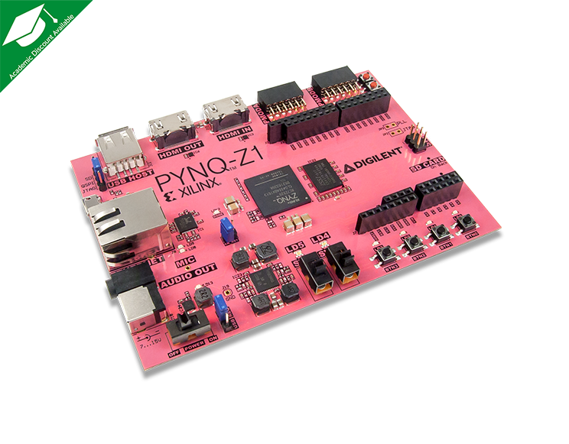

Figure 1: PYNQ-Z1 board [5]

## Fractals

A fractal is defined as “A curve or geometrical figure, each part of which has the same statistical character as the whole. They are useful in modelling structures (such as snowflakes) in which similar patterns recur at progressively smaller scales, and in describing partly random or chaotic phenomena such as crystal growth and galaxy formation.” [6]

There are many different fractals with varying features, but the initial focus can only be on one of them. Following is an overview of individual fractals considered and the decision process behind choosing the ideal one to be used in this project.

### Sierpinski Triangle

Relatively simple fractal constructed by executing the following steps: [7]

1. Start with a single triangle.
2. Remove a reversed half-sized triangle from all current triangles, effectively tripling the number of current triangles.
3. Repeat step 2 until the desired depth has been achieved.

A generated image of this fractal can be seen in figure 2. This fractal can also be generated as an Iterated Function System (IFS). It is not defined by an equation and by definition the values of individual pixels of its plot depend on each other. [7] This means that it cannot be generated as a stream of independent pixels but requires an image to be stored in memory while computations are performed on the image.

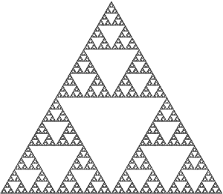

Figure 2: Sierpinski Triangle [8]

### Iterated Function System

An iterated function system (IFS) is a method of constructing a fractal as a union of copies of the fractal itself, where each copy is transformed by a function. Sierpinski Triangle can be considered a part of the IFS, even though It can be constructed using other methods as well. A good example of IFS is a Barnsley’s fern which can be seen in figure 3. These fractals are most commonly computed using the chaos game algorithm, which creates dependencies between individual pixels of the image while the fractal is being generated. [9] The implications derived from the fractal generation are the same as for Sierpinski triangle, the generation process would require an intermediate image representation to be stored in memory while computations and modifications are being performed on the image.



Figure 3: Barnsley's fern [10]

### Mandelbrot Set

Mandelbrot set is defined as a set of complex numbers *c* for which the function (1) does not diverge when iterated from $z=0$. [11] To achieve better visual results when computing the fractal, the individual pixels of the generated image are assigned a colour based on how fast they diverge (how many iterations it takes to exceed a fixed threshold value, such as 4), which forms a colour gradient around the Mandelbrot set itself and creates interesting patterns. The pixels whose values do not diverge (do not exceed the threshold value after a certain number of iterations have been calculated) can be assigned special colour to distinguish them from the rest of the pixels. Each pixel can be calculated independently which makes it easy to generate this fractal as a stream of independent pixels on a piece of hardware. An example of a Mandelbrot set with grayscale coloured environment can be seen in figure 4.

$$\begin{aligned}f_{c}\left(z\right)=z^{2}+c \#\left(1\right)\end{aligned}$$

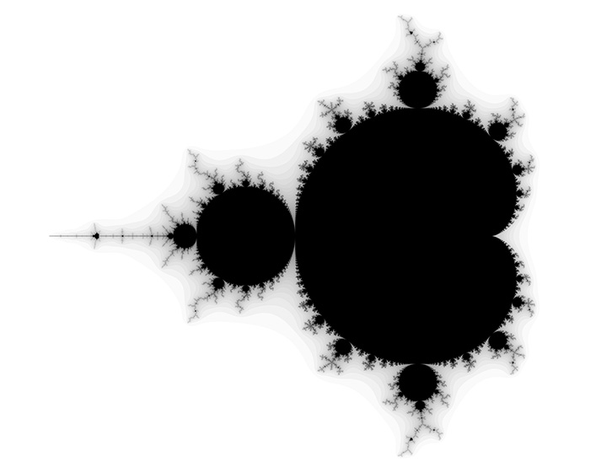

Figure 4: Mandelbrot set [12]

### Julia Set

Julia set is another example of a common fractal. It is closely related to the Mandelbrot set. Its mathematical definition is relatively complex, but its computation is very similar to the Mandelbrot set (with the actual computation of the next iteration being somewhat more complicated). It is defined by an equation and it can be computed as a stream of pixels without the need for intermediate data storage, since each pixel is independent of each other. Its colouring can also follow the same principles as Mandelbrot set and results in visually interesting plots. An example of a Julia set fractal with coloured environment can be seen in figure 5.



Figure 5: Julia set [13]

### Choosing the Right Fractal

Considering the main differences between the Sierpinski Triangle and the Iterated Function Systems compared to the Julia Set and the Mandelbrot Set in terms of rendering and ease of implementation, the latter two seem to be more straight forward to implement since they are defined by an equation and the individual pixels are independently generated, which mitigates the need for storing intermediate image state in memory. They are also subjectively more aesthetically interesting to explore. The Mandelbrot set is overall simpler and will be used as a starting point. The Julia set might be implemented later as a comparison and variation to the existing Mandelbrot implementation if the time permits.

# Software Implementation

## Programming Language

The software to compute the Mandelbrot set fractal needs to be implemented in Python so that it can be executed on the PYNQ-Z1 board. The highest version of Python supported by the device at this point in time is 3.6 which is the one that will be used for the implementation and throughout this project. [14]

## Architecture

To achieve good decoupling of individual areas of the code, the MVC (model, view, controller) design pattern is used. The aim of the pattern is to separate the application logic (model) from the user interface and the output (view) by separating them into individual modules that are independent of each other. The interaction between these two modules is facilitated by a third separate module that controls the application and its execution (controller). The idea is that if the design for the view or the model changes in the future, perhaps different front-end library needs to be used for the view, the other module should be completely unaffected. The controller is the only module that needs to adapt to a change in either model or view and is essentially a kind of an interface between the two. [15]

### Model

The model consists of a single class called *Mandelbrot* with its main function *calculate* that calculates the fractal image based on the current configuration and returns the result. The algorithm iterates over all the pixels on the screen. For each pixel, given its coordinates in the plot of real axis $x_{0}$ and imaginary axis $y_{0}$ it iteratively computes the equations (2), (3), (4) and (5), where during the first iteration the initial values for $x$ and $y$ are $x=x_{0}$ and $y=y_{0}$, until either the maximum number of iterations has been reached or until the value of $x^{2}+y^{2}$ starts to diverge beyond the threshold value of $4$ (the condition $x^{2}+y^{2}>4$ is true). [11]

$$\begin{aligned}z^{2}={(x+iy)}^{2}=x^{2}+i2xy-y^{2}\#\left(2\right)\end{aligned}$$

$$\begin{aligned}c=x_{0}+iy_{0}\#\left(3\right)\end{aligned}$$

$$\begin{aligned}x=Re\left(z^{2}+c\right)=x^{2}-y^{2}+x_{0}\#\left(4\right)\end{aligned}$$

$$\begin{aligned}y=Im\left(z^{2}+c\right)=2xy+y_{0}\#\left(5\right)\end{aligned}$$

The number of iterations it takes to reach the condition will be used to determine the colouring of the pixel. If the value never diverges, in other words if the maximum number of iterations has been reached, the number used to determine the colour will simply equal to the maximum number of iterations. These non-diverging pixels can potentially be represented by a unique colour to make them stand out from the rest.

Based on these observations, an implementation of the model was created and can be seen in code listing 1. The source code was stored in a *model* module folder in a *Mandelbrot_SW.py* file. It contains a *Mandelbrot* class definition with a single *calculate* function that returns the iteration values achieved based on its arguments.

Code listing 1: Model implementation in file Mandelbrot_SW.py

class Mandelbrot:

    def calculate(self, x_scale, y_scale, plot_width, plot_height, max_iteration):

        v_min = max_iteration

        v_max = 0

        iterations = [[0 for _ in range(plot_width)] for _ in range(plot_height)]

        scale_width = x_scale[1] - x_scale[0]

        scale_height = y_scale[1] - y_scale[0]

        for plot_x in range(plot_width):

            for plot_y in range(plot_height):

                """calculate pixels"""

                x_scaled = x_scale[0] + plot_x / plot_width * scale_width

                y_scaled = y_scale[1] - plot_y / plot_height * scale_height

                x = 0.0

                y = 0.0

                iteration = 0

                while x*x + y*y < 4 and iteration < max_iteration:

                    temp = x*x - y*y + x_scaled

                    y = 2*x*y + y_scaled

                    x = temp

                    iteration = iteration + 1

                iterations[plot_y][plot_x] = iteration

                if iteration < v_min:

                    v_min = iteration

                if iteration > v_max:

                    v_max = iteration

        return {

            "values": iterations,

            "vMin": v_min,

            "vMax": v_max

        }

Notice there are two additional variables, *v_min* and *v_max*, that are used to keep track of the lowest and highest iteration achieved in the calculation. They are returned along with the iteration values to help the view with the colouring, so that the colours can be interpolating between these two values instead of zero and *max_iteration*. This helps to achieve better colour contrast in a render and provides superior results.

### View

To render the output, the standard *matplotlib* library plotting framework *pyplot* is used to create a figure and then show the resulting image with the *gist_stern* colormap. The implementation is shown in code listing 2 as contents of *MatplotlibView.py* file inside a *view* module.

Code listing 2: View implementation in file MatplotlibView.py

import matplotlib.pyplot as plt

class MatplotlibView:

    def __init__(self, resolutionX, resolutionY):

        self.resolution = [resolutionX, resolutionY]

        self.dpi = 300

        self.size = [resolutionX/self.dpi, resolutionY/self.dpi]

        plt.figure(figsize=self.size, dpi=self.dpi)

    def render(self, values, v_min, v_max):

        plt.imshow(

values,

"gist_stern",

vmin=v_min,

vmax=v_max,

extent=(-2.5, 1.0, -1.0, 1.0)

)

        plt.show()

### Controller

The last module, controller, is simply gluing the view and the model together, calling the *calculate* method on the model and passing the result to the view. It needs to be passed both the view and the appropriate model during its construction and can be run by simply calling its update method with appropriate arguments. The resulting implementation can be seen in code listing 3 and represents the contents of the *Controller.py* file inside the *controller* module.

Code listing 3: Controller implementation in file Controller.py

class Controller:

    def __init__(self, model, view):

        self.model = model

        self.view = view

    def update(self, x_scale, y_scale, max_iteration):

        result = self.model.calculate(

x_scale=x_scale,

y_scale=y_scale,

plot_width=self.view.resolution[0],

plot_height=self.view.resolution[1],

max_iteration=max_iteration

)

        self.view.render(

values=result["values"],

v_min=result["vMin"],

v_max=result["vMax"]

)

## Results

The python implementation functions both on a regular PC with Python 3.6 and appropriate libraries installed as well as inside a Jupyter notebook on the PYNQ-Z1 board. After importing the modules and constructing them, the update method can be called to display the output. An example script used for execution on a PC can be seen in code listing 4. It also contains a timer to measure the rendering speed. The resulting plot can be seen in figure 6. This particular render took 151.7 seconds and was performed on a personal desktop computer inside IntelliJ.

Code listing 4: Example execution script

import time

from model.Mandelbrot_SW import Mandelbrot

from view.MatplotlibView import MatplotlibView

from controller.Controller import Controller

model = Mandelbrot()

view = MatplotlibView(1920, 1080)

controller = Controller(model, view)

start: float = time.time()

controller.update(x_scale=[-2.5, 1], y_scale=[-1, 1], max_iteration=1000)

end = time.time()

print("Render took:", end - start, "s")

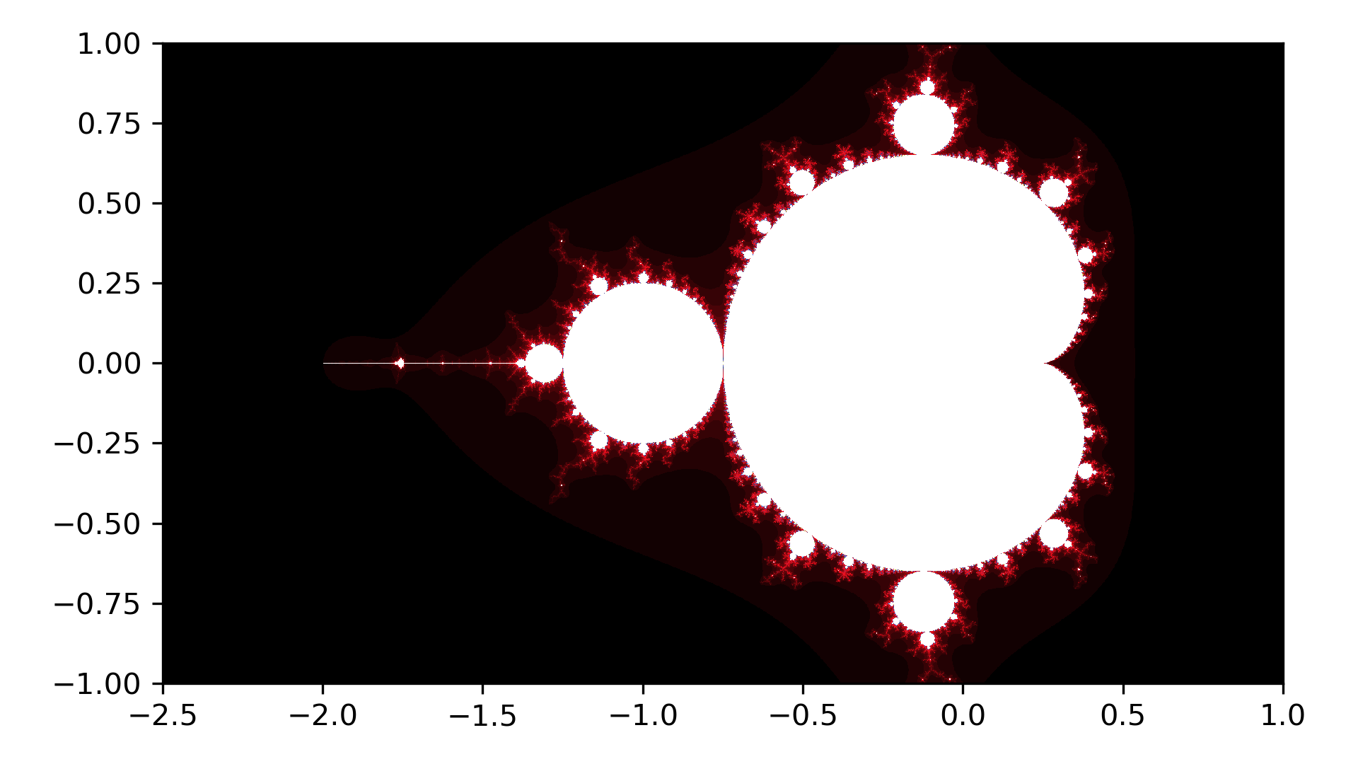

Figure 6: Resulting plot

To run the example code inside Jupyter it is necessary to make sure that all the source files are in directories listed in the path or that the directory where the source files are contained is appended to the path. To properly display the figure in Jupyter, a *%matplotlib inline* magic function needs to be included at the top of the code. This can be seen in code listing 5. The result of this script is identical to the one in figure 6. The amount of time it takes to render the plot on the PYNQ-Z1 board is 2004.5 seconds, which is much higher than how long it took to render on a desktop computer. This is most certainly caused by the processing power difference between a regular desktop computer and a PYNQ-Z1 board.

Code listing 5: Jupyter notebook execution script on PYNQ-Z1

%matplotlib inline

import time

import sys

sys.path.append("/home/xilinx/RenderingFractalsOnPYNQ-Z1/src/")

from model.Mandelbrot_SW import Mandelbrot

from view.MatplotlibView import MatplotlibView

from controller.Controller import Controller

model = Mandelbrot()

view = MatplotlibView(1920, 1080)

controller = Controller(model, view)

start: float = time.time()

controller.update(x_scale=[-2.5, 1], y_scale=[-1, 1], max_iteration=1000)

end = time.time()

print("Render took:", end - start, "s")

# Hardware Implementation

The design process of developing a hardware accelerated application using the PYNQ framework can be split into following steps:

* Design of IP blocks using an industrial tool/language of choice
  + VHDL (VHSIC Hardware Description Language)
    - Low-level language used to describe digital and mixed-signal systems such as FPGAs and integrated circuits. [16]
  + HLS (high-level synthesis)
    - More high-level approach for describing hardware using C/C++, System C or MATLAB language syntax. [17]
    - Creates digital hardware that implements a behaviour based on an interpretation of an algorithmic description. [17]
* Overlay design using Vivado IP Integrator
  + Uses a catalogue of IPs (both vendor-provided and user-generated) as building blocks to create a complete hardware design that can be exported as a bitstream and used to program an FPGA device.
  + Desired blocks are added to the overlay and the connections between inputs and outputs from various blocks are defined to create a final design of the overlay along with any port-mapping onto peripherals.
  + Blocks can have properties that can be modified to change the way the IP is implemented in the system design.
* Python custom drivers and application design in Jupyter or another IDE
  + A Python script is used to interact with the FPGA using provided libraries on the PYNQ-Z1 board.
  + Drivers can be designed to provide a layer of abstraction between the high-level code of the application logic and the actual low-level interaction with the FPGA, which uses register addresses, interrupts and other implementation specific details, that should be hidden behind a well-designed API provided by these custom drivers.
  + The application is most commonly executed in Jupyter, since its instance is running on the PYNQ-Z1 board, and is easily accessible, but can also be launched inside a terminal instance either through Jupyter or directly through an SSH connection.

All the design steps need to be completed to properly evaluate the design and determine how it runs on the PYNQ-Z1 board. Tools such as C/RTL simulations can be used to test the IP block design before an attempt is made to synthesize it and use it in an overlay design. This speeds up the development significantly since generating an overlay implementation is very time consuming even on modern desktop computers. On the other hand, a working IP does not guarantee that the whole design will work, since the IP interacts with other blocks in the overlay and so the only way to make sure that the design works is to test it on the board itself. Because of this, the design process is highly iterative, attempting to build simple solutions first, test them thoroughly, and then build on top of them. This ensures that there is a working solution at any point in time and it becomes easy to demonstrate the progress made since last implementation and the effects of individual improvements in the design on the overall performance.

The IP will be designed using HLS. The reason for this is that the author is more familiar with C/C++ programming compared to VHDL, which should lower the learning curve required. The aim is also to determine how exactly HLS compares to regular C/C++ programming or OpenCL kernel programming, this project provides some insight on this. Vivado HLS was chosen as the design tool, since it’s provided by Vivado and should be compatible with Vivado IP Integrator out of the box.

## Project Structure

Because of the design process mentioned above the hardware design consists of three separate sub-projects, one for each part of the design process. This means that each iteration of the design will contain three parts:

* HLS IP project created in Vivado HLS using C++
* Overlay project created in Vivado IP Integrator
* Jupyter notebook and any Python scripts created on the PYNQ-Z1 board

When creating the sub-projects in their specific development environments, the target device is specified to be *xc7z020clg400-1* where appropriate, which is the FPGA used in the PYNQ-Z1 board. [18] The HLS project needs to be further split into source files and a testbench for testing the design. After analysing the software implementation, the following structure was defined, containing three source files to define the IP and a testbench to test it using C-Simulation before synthesis:

* Mandelbrot.cpp
  + Main file containing the root function and the computation logic
* Mandelbrot.h
  + Main file header with include statements and function signatures
* Config.h
  + Header file containing a *Config* struct grouping all the inputs
* Mandelbrot_tb.cpp
  + Testbench for C-Simulation testing of the IP design before synthesis

## Single Pixel Calculation

### IP Design in Vivado HLS

The initial design iteration consists of a simple Calc_pixel IP core that calculates the iteration value of a single pixel. The top-level function in this case is called *calc_pixel* and is essentially the inner-most loop of the *calculate* function from the Python code, which means that it also needs to be passed the pixel location along with the *Config* struct.

The *Config* struct is grouping all the variables needed to define the image to be rendered, such as its size, location, zoom etc. The calculation of the width and height can be skipped by passing them as inputs, and since only the top left corner (starting point of a pixel data stream) coordinates of the image are needed along with the width and height, the other unused coordinates can be removed from the input. This leaves the following *Config* struct variables:

* Image height in pixels (integer)
* Image width in pixels (integer)
* Plot width in coordinates (decimal)
* Plot height in coordinates (decimal)
* Plot left-most *x* value (decimal)
* Plot top-most *y* value (decimal)
* Maximum number of iterations (integer)

The actual content of the *Config.h* file can be seen in code listing 6. Pre-processor directives at the beginning and the end of the file are present to prevent the file from being loaded twice and they were included after observing example HLS designs and libraries provided by Xilinx and encountering errors in Vivado HLS complaining about the file being loaded multiple times.

Code listing 6: Config.h

#ifndef _CONFIG_H_

#define _CONFIG_H_

struct Config {

int img_width;

int img_height;

double plot_width;

double plot_height;

double plot_x_min;

double plot_y_max;

int max_iteration;

};

#endif

The *Mandelbrot.h* file with its *calc_pixel* function signature and include statements can be seen in code listing 7. The pointer to the *iteration* variable location is passed to the function as an output location. The whole file is again wrapped in pre-processor directives to prevent it from being loaded twice.

Code listing 7: Mandelbrot.h

#ifndef _MANDELBROT_H_

#define _MANDELBROT_H_

#include "Config.h"

void calc_pixel(int img_x, int img_y, int* iteration, Config& config);

#endif

The main design of the IP, the top-level function implementation, is contained in the *Mandelbrot.cpp* file shown in code listing 8. It resets the *iteration* variable before the main loop and then keeps incrementing it. The input and output interfaces are defined using the pragma directives at the top of the function body. The *HLS Interface* pragmas are used for all the input and output ports as well as the return port. The mode is specified as *s_axilite*, which implements the ports as an AXI4-Lite interface. The *return* port is specified so that the IP control interface is implemented which provides registers that initiate its processing and monitor its status. [19]

Code listing 8: Mandelbrot.cpp

#include "Mandelbrot.h"

void calc_pixel(int img_x, int img_y, int* iteration, Config& config) {

#pragma HLS INTERFACE s_axilite port=config

#pragma HLS INTERFACE s_axilite port=iteration

#pragma HLS INTERFACE s_axilite port=img_y

#pragma HLS INTERFACE s_axilite port=img_x

#pragma HLS INTERFACE s_axilite port=return

double x_scaled = config.plot_x_min

+ (double)img_x / (double)config.img_width * config.plot_width

;

double y_scaled = config.plot_y_max

- (double)img_y / (double)config.img_height * config.plot_height

;

double x = 0.0;

double y = 0.0;

*iteration = 0;

while (x*x + y*y < 4 && *iteration < config.max_iteration) {

double temp = x*x - y*y + x_scaled;

y = 2*x*y + y_scaled;

x = temp;

*iteration = *iteration + 1;

}

}

The IP should be tested before it is exported into a catalogue. As already mentioned in section 5, there are two ways how to test the design, either using a C Simulation or a C/RTL Co-Simulation. A test bench file is needed, which functions like a regular C/C++ application entry point with a main method. It is used to produce inputs for the IP and capture the output. C Simulation simply executes the C/C++ code and outputs any results. C/RTL Co-Simulation generates waveform data on top of the simulation and is generally much more detailed since the actual circuit interaction can be observed, but it takes much longer to execute and can usually only capture a very small timeframe. The content of the test bench file *Mandelbrot_tb.cpp* used for the simulations is shown in code listing 9. It makes two calls to the *calc‑pixel* function, one that gets the iteration value in the top left corner of the image and the other one that gets the iteration value in the middle of the image. The configuration is kept identical to the one used to render the image in figure 6. It should thus output 0 and 1000 respectively for the two calls. It does not provide thorough testing, but rather an indicator that the result should be somewhat correct. At this point the IP can be synthesized and exported into Vivado IP catalogue so that it can be used in the overlay design. If the IP is modified due to mistakes or bugs it can be simply exported again and then updated inside Vivado IP Integrator.

Code listing 9: Mandelbrot_tb.cpp

#include <iostream>

#include "Mandelbrot.h"

#include "Config.h"

using namespace std;

int main () {

Config config;

config.img_width = 1920;

config.img_height = 1080;

config.plot_x_min = -2.5;

config.plot_y_max = 1.0;

config.plot_width = 3.5;

config.plot_height = 2.0;

config.max_iteration = 1000;

int iteration;

calc_pixel(0, 0, &iteration, config);

cout << iteration << endl;

calc_pixel(960, 540, &iteration, config);

cout << iteration << endl;

return 0;

}

### Overlay Design in Vivado IP Integrator

The block diagram integrating the Calc_pixel IP was developed in Vivado IP Integrator and can be seen in figure 7. The design is relatively simple since not many additional blocks are needed to support the IP functionality. After running the connection automation, only few modifications need to be performed. An AXI Interrupt Controller is added to handle the interrupt output from the *calc_pixel* block. The *IRQ_F2P* fabric PL-PS interrupt port on the ZYNQ7 Processing System is enabled, into which the *irq* output from the AXI Interrupt Controller is connected. The rest is a standard setup (single 100 MHz clock and its Processor System Reset) generated by Vivado. The resource utilisation is recorded in table 1 and is relatively low because of the small and simple overlay design at this point.

Table 1: Resource utilization

|  |  |  |  |
| --- | --- | --- | --- |
| Resource | Utilization | Available | Utilization % |
| LUT | 9842 | 53200 | 18.50 |
| LUTRAM | 214 | 17400 | 1.23 |
| FF | 9533 | 106400 | 8.96 |
| DSP | 28 | 220 | 12.73 |
| BUFG | 1 | 32 | 3.13 |

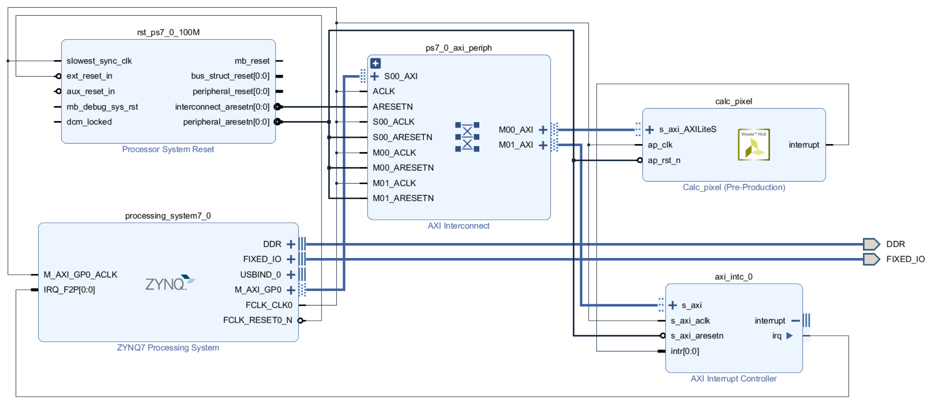

Figure 7: Overlay design in Vivado IP Integrator

### Python Drivers and Jupyter Notebook Design

The software implementation can be mostly reused in this case since the IP block only represents the inner most loop of the calculate function. The *Mandelbrot_SW.py* file is duplicated and modified into *Mandelbrot_HW.py* file shown in code listing 10.

The *Mandelbrot* class is passed a reference to the IP default driver and enables interrupts for the IP state (only *ap_done* needed in this case) in the constructor. The *asyncio* library is used to handle the interrupts. The *struct* library is used for packing 64‑bit double-precision floating-point values as bytes into appropriate registers.

All register locations are taken from the files generated by Vivado HLS, in this case the *xcalc_pixel_hw.h*, which specifies the address offsets used for Memory-mapped input/output (MMIO) commands, such as *read* and *write*.

Initially all the configuration variables are written into their appropriate AXI Lite memory locations. Then, inside the nested loop, the current pixel *x* and *y* values are written to their registers and the *ap_start* control signal is set high (bit 0 at offset 0x00). While the interrupt status register for *ap_done* is low, the *asyncio* waits for another interrupt. When an interrupt is received, and the condition is met, the interrupt register is cleared along with the *interrupt* object that facilitates the interrupt functionality. The resulting *iteration* value is then read from its register location.

Once the overlay and Python files are present on the device, a Jupyter notebook can be used to include the Python scripts, program the FPGA with the overlay and initialise the environment before calling the *update* method of the controller to generate an output. The content of the Jupyter notebook used to carry out these tasks and print the time it takes to render an output can be seen in code listing 11.

Code listing 10: Hardware model implementation in file Mandelbrot_HW.py

import struct

import asyncio

class Mandelbrot:

    def __init__(self, ip):

        self.ip = ip

        # Enable interrupts for ap_done

        self.ip.write(0x04,1)

        self.ip.write(0x08,1)

    def calculate(self, x_scale, y_scale, plot_width, plot_height, max_iteration):

        v_min = max_iteration

        v_max = 0

        iterations = [[0 for _ in range(plot_width)] for _ in range(plot_height)]

        scale_width = x_scale[1] - x_scale[0]

        scale_height = y_scale[1] - y_scale[0]

        self.ip.write(0x28,plot_width)

        self.ip.write(0x30,plot_height)

        self.ip.write(0x38,struct.pack('d', scale_width))

        self.ip.write(0x44,struct.pack('d', scale_height))

        self.ip.write(0x50,struct.pack('d', x_scale[0]))

        self.ip.write(0x5c,struct.pack('d', y_scale[1]))

        self.ip.write(0x68,max_iteration)

        for plot_x in range(plot_width):

            for plot_y in range(plot_height):

                """calculate pixels"""

                self.ip.write(0x10,plot_x)

                self.ip.write(0x18,plot_y)

                self.ip.write(0x00,1)

                # Wait for interrupt

                loop = asyncio.get_event_loop()

                while(self.ip.read(0x0c) & 0x1 == 0):

                    loop.run_until_complete(

asyncio.ensure_future(

self.ip.interrupt.wait()

)

)

                # Clear interrupt

                self.ip.write(0x0c, 0x1)

                self.ip.interrupt.event.clear()

                # Get output

                iteration = self.ip.read(0x20)

                iterations[plot_y][plot_x] = iteration

                if iteration < v_min:

                    v_min = iteration

                if iteration > v_max:

                    v_max = iteration

        return {

            "values": iterations,

            "vMin": v_min,

            "vMax": v_max

        }

Code listing 11: Jupyter notebook execution script on PYNQ-Z1

import sys

import struct

import time

from pynq import Overlay

%matplotlib inline

sys.path.append('/home/xilinx/RenderingFractalsOnPYNQ-Z1/src/')

from model.Mandelbrot_HW import Mandelbrot

from view.MatplotlibView import MatplotlibView

from controller.Controller import Controller

overlay = Overlay('/home/xilinx/pynq/overlays/personal/Mandelbrot/Mandelbrot.bit')

ip = overlay.calc_pixel

model = Mandelbrot(ip)

view = MatplotlibView(1920, 1080)

controller = Controller(model, view)

start = time.time()

controller.update(x_scale=[-2.5, 1], y_scale=[-1, 1], max_iteration=1000)

end = time.time()

print("Render took:", end - start, "s")

### Results

When the Jupyter notebook is executed it produces an output identical to the one showed in figure 6. The render takes 1025.3 seconds to complete. Even though this proof of concept is a successful implementation of hardware accelerated code it is still very slow in its execution. On the other hand, this initial iteration of the design is necessary to understand the concepts of IP and overlay design and verify the correctness of the design before moving onto more complex, faster solution.

## Full Image Calculation

In order to speed up the processing and avoid unnecessary interaction with Python code during execution, the IP should iterate over the pixels on its own and output the whole rendered image. There are two options how this could be achieved, either write the array of iteration values into memory using an AXI Direct Memory Access (DMA) block, before processing and displaying the image using Python code, or stream an already fully processed frame into an AXI Video Direct Memory Access (VDMA) block. [20] VDMA is essentially a DMA but designed for processing frames, which also alleviates the amount of setup and configuration required. A drawback is that the colour processing would need to be done on the PL and might be more difficult to customise. Also, if the pixels are directly streamed out of the IP, the *v_min* and *v_max* variables cannot be used to achieve an adaptive colour interpolation range since there is no way to calculate the highest and lowest iteration values before a full frame is processed. Instead, values of zero and *max_iteration* need to be used instead of *v_min* and *v_max* respectively.

An implementation of a simple HDMI input to VDMA to HDMI output design is present in the *base* overlay provided for the PYNQ boards, including the PYNQ-Z1. There are PYNQ libraries available to interact with VDMA and handle some aspects of video processing, including HDMI I/O. [21] This potentially opens the possibility to stream data to the HDMI output that is present on the device, while still being able to read the frames from Jupyter notebook. The *base* overlay is available for download along with the libraries (both are already included on the PYNQ-Z1 board in the default image) inside the PYNQ repository on Xilinx’s GitHub page. [22] This is an excellent reference for overlay design and a good starting point to learn about complex solution structure by inspecting an example. The availability of the Python library source code also enables its easy inspection, which assist with debugging. The drivers inside the Python library assume a certain structure of the overlay block design, which is because the drivers are specifically designed to work with the *base* overlay. If the VMDA block is used on its own it can simply be located at the top of the hierarchy. Due to all these observations a VDMA based approach will be used in this section.

### IP Design in Vivado HLS

The main *Mandelbrot.cpp* file needs to be majorly rewritten. These changes must in turn be reflected in its header file and the testbench, but the *Config.h* file can remain completely intact as in code listing 6. The contents of the *Mandelbrot.h*, *Manelbrot.cpp* and *Mandelbrot_tb.h* files are shown in code listings 12, 13 and 14 respectively.

An *hls_video.h* library is included in the *Mandelbrot.h* header file to provide definitions of template types used for video processing. The templates required are *hls::stream* to define the output, *hls::Mat* to define a matrix to hold data to be outputted and *hls::Scalar* to define an individual piece of data contained in the matrix. New types based on the included template types are then defined with their descriptive names, where *AXI_STREAM* represents the 32-bit wide AXI Stream interface used to output an image from the IP into VMDA, *RGB_IMAGE* is a 1080p image that can be outputted through that stream and *RGB_PIXEL* is an individual pixel of that image with 3 8-bit colour channels. The IP’s functionality in the *Mandelbrot.cpp* file is split into 3 separate methods to help with overall code readability and decoupling:

* *void mandelbrot(AXI_STREAM& OUTPUT_STREAM, Config& config)*
  + Top level function that handles input and output.
  + A new *img* variable is defined, which is then passed to the *calculate* function for processing before being outputted to *OUTPUT_STREAM.*
  + *AXI_STREAM* output type along with the *DATAFLOW* pragma allow pixels to be streamed from the IP one by one as they become available in the *img* variable, effectively increasing performance. [23]
* *void calculate(Config& config, RGB_IMAGE& img)*
  + Contains the original processing code wrapped in two for‑loops.
  + Result is written into the *img* variable provided as an argument.
* *RGB_PIXEL getPixel(int& iteration, int& max_iteration)*
  + Returns an *RGB_PIXEL* based on the iteration value provided.
  + Colour goes from black to green to white, and loops over.
  + A special case, when *max_iteration* is reached, outputs black.
  + Effectively interpolates between 512 different shades of green.

The rendering coordinates in the testbench have been changed to provide a zoom into an interesting are at the top of the fractal structure. The C-Simulation saves the image and outputs the time it takes to render it. The result of the render is shown in figure 8. The render took 8 seconds to complete on a desktop computer.

Code listing 12: Mandelbrot.h

#ifndef _MANDELBROT_H_

#define _MANDELBROT_H_

#include "Config.h"

#include "hls_video.h"

#define WIDTH                  1920

#define HEIGHT                 1080

typedef hls::stream<ap_axiu<32,1,1,1> >     AXI_STREAM;

typedef hls::Scalar<3, unsigned char>       RGB_PIXEL;

typedef hls::Mat<HEIGHT, WIDTH, HLS_8UC3>   RGB_IMAGE;

void mandelbrot(AXI_STREAM& OUTPUT_STREAM, Config& config);

void calculate(Config& config, RGB_IMAGE& img);

RGB_PIXEL getPixel(int& iteration, int& max_iteration);

#endif

Code listing 13: Mandelbrot.cpp

#include "Mandelbrot.h"

void mandelbrot(AXI_STREAM& OUTPUT_STREAM, Config& config) {

    #pragma HLS INTERFACE s_axilite port=config

    #pragma HLS INTERFACE axis port=OUTPUT_STREAM

    #pragma HLS INTERFACE s_axilite port=return

    #pragma HLS DATAFLOW

    RGB_IMAGE img(config.img_height, config.img_width);

    calculate(config, img);

    hls::Mat2AXIvideo(img, OUTPUT_STREAM);

    return;

}

void calculate(Config& config, RGB_IMAGE& img) {

    // Image coordinates have origin at top left

// Plot coordinates have origin at bottom left

    for(int img_y = 0; img_y < config.img_height; img_y++) {

        for(int img_x = 0; img_x < config.img_width; img_x++) {

            double plot_x = config.plot_x_min

+ (double)img_x / (double)config.img_width * config.plot_width

;

            double plot_y = config.plot_y_max

- (double)img_y / (double)config.img_height * config.plot_height

;

            double x = 0.0;

            double y = 0.0;

            int iteration = 0;

            while (x*x + y*y < 4 && iteration < config.max_iteration) {

                double temp = x*x - y*y + plot_x;

                y = 2*x*y + plot_y;

                x = temp;

                iteration = iteration + 1;

            }

            img.write(getPixel(iteration, config.max_iteration));

        }

    }

}

RGB_PIXEL getPixel(int& iteration, int& max_iteration) {

    RGB_PIXEL result;

    if (iteration < max_iteration) {

        int colour = iteration % 512;

        if (colour > 255) {

            colour = colour - 256;

            result = RGB_PIXEL(colour, 255, colour);

        } else{

            result = RGB_PIXEL(0, colour, 0);

        }

    } else {

        result = RGB_PIXEL(0,0,0);

    }

    return result;

}

Code listing 14: Mandelbrot_tb.cpp

#include <iostream>

#include <ctime>

#include <hls_opencv.h>

#include "Mandelbrot.h"

#include "Config.h"

using namespace std;

int main () {

Config config;

config.img_width = 1920;

config.img_height = 1080;

config.plot_x_min = -1.3;

config.plot_y_max = 0.35;

config.plot_width = 0.35;

config.plot_height = 0.2;

config.max_iteration = 1000;

AXI_STREAM img_axi;

std::time_t start = std::time(nullptr);

mandelbrot(img_axi, config);

std::time_t end = std::time(nullptr);

std::cout << "Render took: " << end-start << " s";

IplImage* img = cvCreateImage(

cvSize(config.img_width, config.img_height),

8,

3

);

AXIvideo2IplImage(img_axi, img);

cvSaveImage("img.bmp", img);

return 0;

}

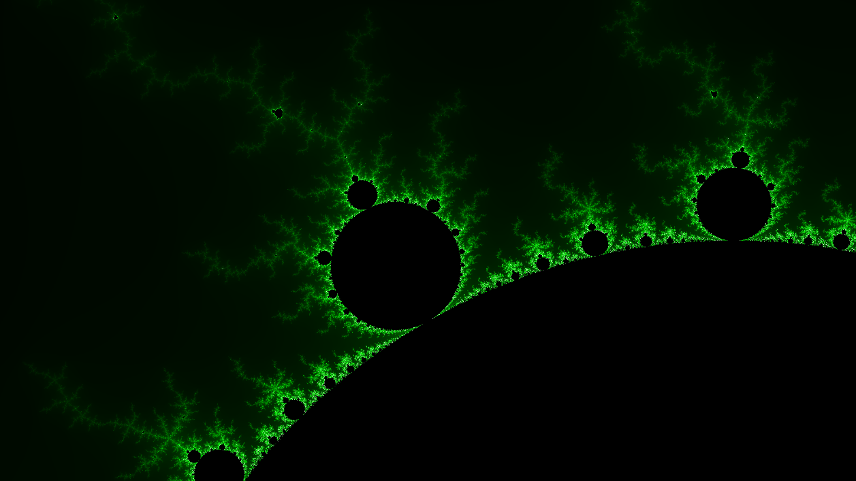

Figure 8: Resulting fractal image

### Overlay Design in Vivado IP Integrator

The design becomes more complicated with stream interfaces and the addition of the AXI Video Direct Access Memory block. The AXI4-Streams can run at a higher clock frequency and so another clock source needs to be added to the design along with its own Processor System Reset block. This can be observed in the *base* overlay design as well as the specification for AXI VDMA block, which specifies the maximum frequency for AXI4-Stream as 150 MHz compared to AXI4-Lite maximum frequency of 120 MHz for Artix-7 FPGA with speed grade -1 (PYNQ‑Z1 specification). [24] [5] This is confirmed in the documentation for the PYNQ-Z1 video pipeline. [21] Inside the *base* overlay for PYNQ-Z1 board, inside the *video* hierarchy the AXI Streams are passed through the HDMI hierarchies. After observing the *hdmi_out* hierarchy and its IP components, all the pre-production IPs provided along with the base overlay have a *clk_period* property specified to be 7ns, which translates to about 142.85 MHz. It is important to note that even though an IP might be rated for 100 MHz, which is the standard pre-set in Vivado HLS (10 ns clock cycle), it might still run at 142 MHz without any issues. At this point in the design the target clock period for the Mandelbrot IP was set to 7ns to allow itself and the VDMA block to run at the higher clock speed of 142 MHz which can be provided by the ZYNQ7 Processing System.

Block design of the overlay can be seen in figure 9. The AXI VDMA is added along with another AXI Interconnect, into which the AXI-Stream outputs of the VDMA block are connected. The ZYNQ7 Processing System has been given an additional clock output with a frequency of 142 MHz, *FCLK_CLK1,* which is connected to the new *rst_ps7_0_142M* Processor System Reset block created for this clock. Two interrupts are outputted from the VDMA, *mm2s_introut* and *s2mm_introut.* They are concatenated along with the Mandelbrot IP’s *interrupt* output using a Concat block, which then outputs the concatenated signal into a new AXI Interrupt Controller block. This block outputs its own interrupt signal to the ZYNQ7 Processing System’s *IRQ_F2P* fabric interrupt input which ultimately indicates that an interrupt has been triggered. To enable the ZYNQ7 Processing System to retrieve more information about the interrupt, the AXI Interrupt Controller’s AXI-Lite port is connected to the *ps7_axi_periph* block, which interconnects the ZYNQ7 Processing System’s AXI-Lite interface with the AXI-Lite interface of the other blocks. The clocks are connected accordingly with *FCLK_CLK0* (100 MHz) powering all the AXI-Lite interfaces and *FCLK_CLK1* (142 MHz) powering the AXI-Streams and the Mandelbrot IP. The new AXI Interconnect’s master output is connected to a new *S_AXI_HP0* slave input on the ZYNQ7 Processing System, which also runs at the frequency of 142 MHz. The VMDA block has been modified according to the design in *base* overlay and its properties are now identical to the VDMA contained in the *base* overlay’s *video* hierarchy, except that the number of frame buffers has been decreased to 2, since no more are actually required. The VDMA block’s properties are listed in table 2.

Table 2: AXI Video Direct Memory Access IP properties

|  |  |  |
| --- | --- | --- |
| Property | Write Channel | Read Channel |
| Address Width | 32 | |
| Frame Buffers | 2 | |
| Enable Read/Write Channel | Yes | Yes |
| Memory Map Data Width | 64 | 32 |
| Write/Read Burst Size | 32 | 32 |
| Stream Data Width | 32 | 32 |
| Line Buffer Depth | 4096 | 512 |
| Enable Vertical Flip | No | |
| Fsync Options | s2mm tuser | None |
| GenLock Mode | Master | Slave |
| Alow Unaligned Transfers | No | No |

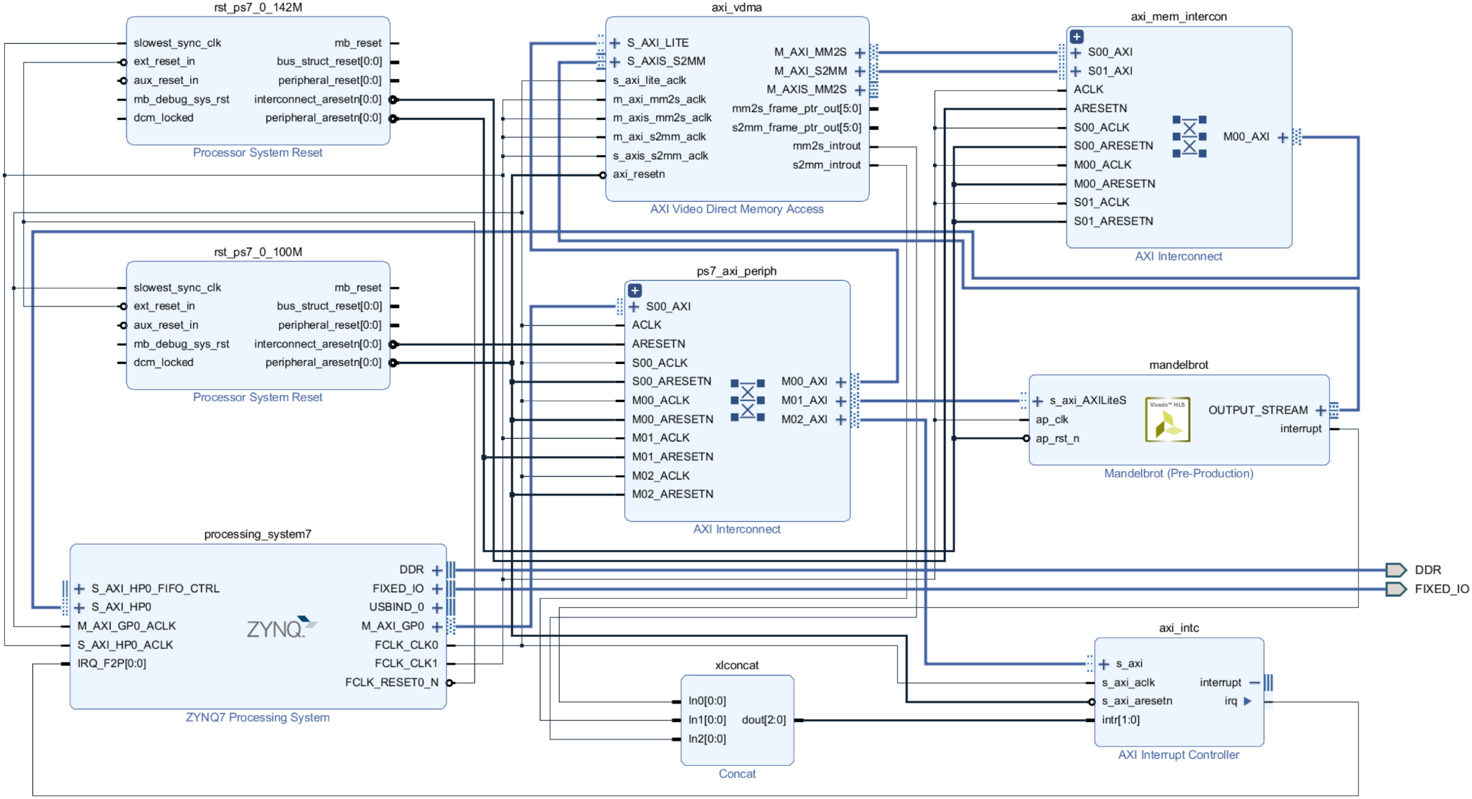

Figure 9: Overlay design in Vivado IP Integrator

### Python Drivers and Jupyter Notebook Design

As the IP and overlay designs becomes more elaborate, so does the Jupyter notebook and its Python code. Since the code is still relatively short, it is kept in a single notebook. The Python scripts used for software implementation and single pixel calculation IP design are no longer required because the pixel-looping and the colour calculations are handled on the FPGA. The notebook is split into 6 cells, all of which can be seen in their consecutive order in code listings 15, 16, 17, 18, 19 and 20.

Code listing 15: Content of cell 1 in Mandelbrot.ipynb Jupyter notebook file

import struct

from pynq import Overlay

from pynq import DefaultIP

from pynq.lib.video import *

import time

import PIL.Image

import asyncio

Initially, in the first cell, the required libraries that are used in other cells are imported. Most libraries have been used before. *DefaultIP* is used as a superclass for custom drivers. The whole contents of the *video* library, containing drivers for VDMA and other dependencies, need to be imported. Last addition to the import statements is the *Image* from the *PIL* library, which is used for rendering an image inside a Jupyter notebook and is used instead of the *Matplotlib* library.

Cells 2 and 3 contain custom drivers declarations. A new *Mandelbrot* class, sub‑classing the *DefaultIP* class, is declared and bound to the Mandelbrot IP. Its constructor calls the superclass constructor and then sets up the IP itself, enabling interrupts and using *resolution* and *config* functions to set up the default configuration values. These methods along with all the setters can be used to modify the fractal configuration in‑between renders. The addresses used have once again been taken from the IP implementation files generated by Vivado HLS. The *render* function is very similar to the code of the inner for-loop in the previous iteration Python code, with the only difference that instead of reading single iteration value from a register, the VDMA driver is used to read the *frame* from the *readchannel* directly. An *Image* object is then constructed by calling the *fromarray* function, providing the *frame*. Lastly the *timed_render* function is simply measuring the time it takes the *render* function to finish using the *time* library and then outputs its result.

Code listing 16: Content of cell 2 in Mandelbrot.ipynb Jupyter notebook file

class Mandelbrot(DefaultIP):

    def __init__(self, description):

        super().__init__(description=description)

        # Enable interrupts for ap_done

        self.write(0x04,1)

        self.write(0x08,1)

        # Setup default resolution

        self.resolution(1920, 1080)

        # Setup default config

        self.config(3.5, 2.0, -2.5, 1.0, 100)

    bindto = ['xilinx.com:hls:mandelbrot:1.0']

    def resolution(self, img_width, img_height):

        self.write(0x10,1920)

        self.write(0x18,1080)

    def config(self, plot_width, plot_height, x_min, y_max, iterations):

        self.write(0x20,struct.pack('d', plot_width))

        self.write(0x2c,struct.pack('d', plot_height))

        self.write(0x38,struct.pack('d', x_min))

        self.write(0x44,struct.pack('d', y_max))

        self.write(0x50,iterations)

    def set_plot_width(self, plot_width):

        self.write(0x20,struct.pack('d', plot_width))

    def set_plot_height(self, plot_height):

        self.write(0x2c,struct.pack('d', plot_height))

    def set_x_min(self, x_min):

        self.write(0x38,struct.pack('d', x_min))

    def set_y_max(self, y_max):

        self.write(0x44,struct.pack('d', y_max))

    def set_iterations(self, iterations):

        self.write(0x50,iterations)

    def render(self):

        # Start IP

        self.write(0x00,1)

        # Wait for interrupt

        loop = asyncio.get_event_loop()

        while(self.read(0x0c) & 0x1 == 0):

            loop.run_until_complete(asyncio.ensure_future(self.interrupt.wait()))

        # Clear interrupt

        self.write(0x0c, 0x1)

        self.interrupt.event.clear()

        # Display output

        activeframe = vdma.readchannel.activeframe

        frame = vdma.readchannel._frames[activeframe]

        return PIL.Image.fromarray(frame)

    def timed_render(self):

        start = time.time()

        render = self.render()

        end = time.time()

        print("Render took:", end - start, "s")

        return render

The reason why frames are read directly from the *readchannel* and not through a dedicated function built into the VDMA driver, such as *readframe* or *readframe_async,* is that the interrupt these functions wait for to indicate that a new frame is available is only triggered when the *activeframe* changes, and that only happens once a new frame is being written into. This would normally not be a problem in a video streaming pipeline, since a new frame is being streamed right after the previous one has been finished, but in the current design this does not happen. A new frame is being streamed only after the IP has been activated again, only after the subsequent IP activation the previous frame could be read, which for obvious reasons is not ideal. A workaround to make the frame available right after the IP finished processing, without the need to activate it again, is to completely ignore the VDMA interrupts and read the active frame directly from the *readchannel* after the *ap_done* interrupt has been raised. This is exactly what is happening inside the *render* function.

Code listing 17: Content of cell 3 in Mandelbrot.ipynb Jupyter notebook file

class AxiVDMA_Custom(pynq.lib.video.dma.AxiVDMA):

    def __init__(self, description):

        super().__init__(description=description, framecount=2)

    bindto = ['xilinx.com:ip:axi_vdma:6.3']

In cell 3 a custom driver is sub-classed from the *AxiVDMA* driver and bound to the VDMA IP. It is declared only to override the default value of *framecount* used in the driver from 4 to 2, which it accomplishes simply by calling the super-constructor with the appropriate parameters.

Code listing 18: Content of cell 4 in Mandelbrot.ipynb Jupyter notebook file

overlay = Overlay('/home/xilinx/pynq/overlays/personal/Mandelbrot/Mandelbrot.bit')

mandelbrot = overlay.mandelbrot

vdma = overlay.axi_vdma

vdma.readchannel.mode = common.VideoMode(1920, 1080, 32)

vdma.readchannel.start()

After all the libraries have been imported and all the drivers declared, the overlay can finally be loaded in cell 4. Afterwards, all the drivers are retrieved from the resulting *overlay* variable. Lastly, the VDMA’s *readchannel* mode is configured for 1080p resolution, 32 bits per pixel video stream, and is started.

Code listing 19: Content of cell 5 in Mandelbrot.ipynb Jupyter notebook file

mandelbrot.config(0.35, 0.2, -1.3, 0.35, 1000)

Code listing 20: Content of cell 6 in Mandelbrot.ipynb Jupyter notebook file

mandelbrot.timed_render()

The last two cells are used for rendering the results onto the screen. Cell 5 contains a call to the *config* function with the coordinates used to render image on figure 8 and cell 6 calls the *timed_render* function to display the time it took to process the image and then display the image itself.

### Results

The resulting image produced is identical to figure 8 and the render takes 227.6 seconds on the PYNQ-Z1 board, which is much slower than the 8 seconds it took to simulate the IP using a C-Simulation. This might initially come as a surprise since the C-Simulation is faster and the difference is so massive, but it actually makes a lot of sense. There has been no pipelining, no optimisation and no parallelisation of the processing on the FPGA. The processing is happening sequentially and with low clock speeds of the FPGA, so it is no wonder that the current design can’t compete with a low‑footprint C code running on a modern desktop computer.

## Optimised IP Design

There are many ways to optimise a design in HLS beyond the standard C/C++ code optimisation. The reason is that there are many directives available that dictate how the code should be translated into an RTL code. [25] Another possible optimisation is to change the data types used throughout the design, especially considering a use of fixed-point numbers instead of floating-point numbers and possibly only using 32-bit values instead of currently implemented 64‑bit values. This would normally not make a difference when executing code on a 64-bit CPU, but an FPGA can be designed to process variables of any arbitrary bit-length, only using resources necessarily needed to carry out the computation, effectively making the design more efficient.

There are many steps and considerations covered in this section. The subsections group up major steps in optimising the code. The resulting optimised solution is listed in code listings in subsection 5.4.5 at the end of this section.

### Pipelining the Execution

An inclusion of the *pipeline* directive inside the inner loop allows the processing to be pipelined and thus the throughput to be increased. [25] It is necessary that the calculation carried out in any single iteration of the inner loop is not dependent on the results obtained in several of the previous iterations, so that the processing of the current iteration can carry on without having to wait for the previous iterations still in the pipeline to finish executing if it needs to use their resulting data.

The way such data independence can be achieved is by calculating a given iteration for all the pixels in a row at once and moving onto the next iteration only after the whole row of pixels has been processed. This requires a data structure storing all the required values needed to compute the next iteration to be stored and maintained inside the IP in form of an array. The pipeline can then loop through this collection, using the values already present, and update the values in the collection once new values have been calculated. This continues until *max_iteration* has been reached. Of course, for some pixels the values are already diverging, and the *iteration* value will not be updated, and no more calculations are necessary, which wastes some resources, but it is necessary to maintain the pipeline. On average, the performance increase from pipelining the processing and keeping all hardware blocks occupied should be greater than the presented overhead. It also keeps the processing time consistent, since it does not matter which coordinates of the fractal are being processed, because all iterations will be calculated, and the render time will remain constant. The while‑loop is removed, but its content is kept. The inner for-loop iterating over the row of pixels is wrapped in another for-loop which now loops until *max_iteration* has been reached. A new for-loop was created to accommodate the pixels’ colour calculation, writing them into the *img* variable as well as initializing the new arrays before processing begins, which has all been removed from the *processing* loop. This introduces a couple of changes to the overall flow:

* Loop over all image rows and add one extra iteration after last row
  + Loop over all pixels in a row
    - Write into *img* unless this is the first iteration
    - Initialise the arrays unless this is the extra iteration
  + Process the row of pixels unless this is the extra iteration

The extra iteration at the end is introduced so that the writing of pixels can be kept before the *processing* loop along with the initialisation code. This allows another *pipeline* directive to be inserted into this *maintenance* loop so that the writing of pixels is pipelined with the initialisation, since it only makes sense that a pixel would be written and then its values erased immediately afterwards. This small optimisation speeds up these extra maintenance tasks and increases the overall performance.

The arrays storing the current variable values are created at the top of the *calculate* function. The array variable names, along with short descriptions, are listed in table 3.

Table 3: Values stored for each pixel needed to calculate the next iteration

|  |  |
| --- | --- |
| Variable | Description |
| x_0 | X-coordinate (initial value of x); remains unchanged for all iterations |
| y_0 | Y-coordinate (initial value of y); remains unchanged for all iterations |
| x | Current value of x; updated on every iteration |
| y | Current value of y; updated on every iteration |
| iter | Current iteration for the pixel, only updated if values do NOT diverge |

The calculations remain unchanged, but the variables are now elements of the arrays and are accessed with the loop index. This also means that the arrays need to be as wide as the maximum number of pixels in a row which is defined by *WIDTH*.

### Unrolling Loops and Parallelisation

The calculation of each pixel’s iteration value is independent. This means that the computation can happen simultaneously for any number of pixels at a time. This can be exploited to create multiple copies of the same processing hardware to multiply the speed at which the IP can render images without having any effect on the computation. Currently the IP processes a full row of pixels at a time. The goal is to be able to process multiple rows simultaneously, while also allowing for individual rows to be split into sections, where each section within any row can be processed by its own copy of the processing hardware. The row of pixels is long enough so that it can be split into several sections without endangering the pipeline consistency, which enables the increase of parallelism of the IP without increasing the already high BRAM_18K usage consumed by the arrays, which would otherwise limit the number of processing hardware copies that could be created since there would simply not be enough memory. To allow the degree of parallelism to be easily controlled there are three new constants defined in the *Mandlebrot.h* file:

* *PARALLEL_LOOPS*
  + Defines how many rows of pixels are being processed at a time
* *PARALLEL_SUB_LOOPS*
  + Defines how many sections each of the rows should be split into
* *SUB_LOOP_WIDTH*
  + Defines the width in pixels of individual sections that a row of pixels is split into by dividing the pixel row width with the number of sections

The end-point number of parallel processing hardware blocks created is defined as a product of *PARALLEL_LOOPS* and *PARALLEL_SUB_LOOPS*.

To accommodate the functionality, the processing code was extracted into a separate function called *subLineProcess*. This function represents an individual processing hardware block that is copied across the FPGA to allow for parallel processing. It is passed its appropriate arrays and thus processes its own section of a row of pixels. It is kept pipelined in its inner-most loop.

The structure of all the loops iterating over rows of pixels and the pixels themselves are transformed to respect the following flow hierarchy:

* Loop over all pixel rows, processing *PARALLEL_LOOPS* rows at a time
  + Loop over *PARALLEL_LOOPS* individual pixel rows, one by one
    - Loop over *PARALLEL_SUB_LOOPS* sections of a pixel row
      * Loop over individual pixels in a row section

By adding a complete *unroll* pragma directive into 2nd and 3rd level loops (loop over individual pixel rows and loop over sections of a pixel row respectively) the processing will be effectively parallelised by a degree equal to the product of *PARALLEL_LOOPS* and *PARALLEL_SUB_LOOPS*. [25]

The array variables are made compatible with the parallelisation by receiving 2 extra dimensions, first one being of the size of *PARALLEL_LOOPS* and second one beingof the size of *PARALLEL_SUB_LOOPS.* The third one (defined in section 5.4.1 to be equal to *WIDTH*) is transformed to be of a size of *SUB_LOOP_WIDTH* instead. The outer loop *unroll* splits the arrays across their first dimension and the inner loop *unroll* splits them across the second dimension. Every single processing hardware copy thus receives only a standard 1-dimensional array as parameter. In order to enforce the data independence at the hardware level so that the processing hardware blocks can access their arrays independently without conflicting with other processing hardware blocks, the arrays are partitioned across the first and second dimensions completely by including the *array_partition* directives with a *complete* keyword for dimensions 1 and 2 immediately after each of the arrays’ declaration. [25]

The values of *PARALLEL_LOOPS* and *PARALLEL_SUB_LOOPS* can be modified based on how much space is left on the FPGA so that the highest level of parallelisation is achieved. This can vary based on the overall overlay design.

### Fixed-Point vs. Floating-Point and Arbitrary Precision Data Types

There are libraries provided for HLS containing definitions of arbitrary precision data types for integers and fixed-point decimal numbers. [26] While this is not applicable to CPU computation, hardware is quite different as it creates circuits to accommodate the number of bits defined, and the amount of hardware space required can be decreased by using only as many bits as is really necessary. This can in turn allow more copies of the processing hardware to be created when parallelising the computation. It might also decrease the number of clock cycles it takes to carry out an arithmetic operation, which improves pipelining efficiency. The question is how well a fixed‑point implementation performs in comparison to a floating‑point implementation in terms of resource usage and precision when zooming.

A new fixed‑point arbitrary precision decimal number data type is defined in the header file *Mandelbrot.h* using the *ap_fixed* library included at the top of the file. The data type definition can be seen in code listing 21.

Code listing 21: Fixed-point data type definition

typedef ap_fixed<32, 4, AP_RND, AP_SAT> fixed_32_4_SAT;

The data type is defined to be 32 bits long so that it is easier to compare it with a float. The number of bits used for integer value is set to 4, which can represent values from -8 to +7. There is no need to use more, since Mandelbrot set only really produces results from -2.5 to +1 on the x-axis and -1 to +1 on the y-axis. Also, to be diverging, a resulting value needs to be bigger than 4, which also fits into the data type. The quantisation mode is set to round to the nearest value (*AP_RND*), and the wrap mode is set to saturation (*AP_SAT*) to prevent wrap around, which could happen since our min/max values are very close to zero. Like this, the values will saturate at their min/max values which prevents nasty errors caused by overflow that can happen during development without saturation specified.

The comparison of the two datatypes is carried out by changing the datatype of variables between the defined fixed‑point type and single precision floating‑point type and comparing both the amount of resources used and the precision achieved at high zoom. It is performed with all optimisations in section 5 in place and thus the total resource usage values are not as important as the relative resource usage of one implementation compared to the other. The resource usage comparison can be seen in table 4. Renders were performed at 2 different high zooms (the first render at lower zoom and the second render at higher zoom for both fixed-point and floating-point designs) with configurations listed in table 5. The resulting renders are shown in figures 10 and 11 for the first render and in figures 12 and 13 for the second render, each time for fixed-point and floating-point implementations respectively.

Table 4: Resource usage for fixes-point and floating-point implementations

|  |  |  |  |
| --- | --- | --- | --- |
| Resource | Fixed-point usage | Floating-point usage | Available |
| SLICE | 4145 | 5974 |  |
| LUT | 9840 | 14556 | 53200 |
| FF | 12048 | 19841 | 106400 |
| DSP48E | 108 | 176 | 220 |
| BRAM_18K | 72 | 72 | 280 |
| SRL | 63 | 517 |  |

It can be seen that the resource usage for fixed-point implementation is much lower than for floating-point. This is the case for all resource types. Especially important is the DSP usage, which is at a very high percentage with regards to the overall availability on the device. Because of this, the fixed-point implementation could potentially achieve a much higher parallelism and thus much higher speed, since the initiation interval of the pipeline is equal to 1 in both implementations, but fixed-point data type allows the implementation to use less resources to achieve it.

Now the focus is on the precision of each implementation. Theoretically the fixed‑point implementation should be more precise since more bits are dedicated to representing decimal places. Even though floating-point values can represent high range of values, in this case the fixed-point data type should have higher precision after sacrificing the range of representable values. The renders ultimately determine which implementation is better suited for this project.

Table 5: Render configurations for precision comparison

|  |  |  |
| --- | --- | --- |
| Variable | First render | Second render |
| Image width (pixels) | 1920 | 1920 |
| Image height (pixels) | 1080 | 1080 |
| Plot width (coordinates) | 0.00007 | 0.0000007 |
| Plot height (coordinates) | 0.00004 | 0.0000004 |
| Plot *x* minimum value (coordinates) | -1.1616267 | -1.1616267 |
| Plot *y* maximum value (coordinates) | 0.29369628 | 0.29369628 |
| Maximum number of iterations | 1000 | 1000 |

The first renders (figures 10 and 11) represent a point when one of the implementations is starting to lose the details and becomes slightly pixelated. The fixed-point implementation is still retaining full resolution, while the floating-point implementation is not. This confirms the initial theory that the extra bits dedicated to representing the values help with the precision, since the goal here is not to represent very low or very high values, but instead to be able to distinguish between very slight changes in values and thus retain high resolution of the render. The floating-point data type fails to provide a high enough resolution while fixed-point is still flawless.

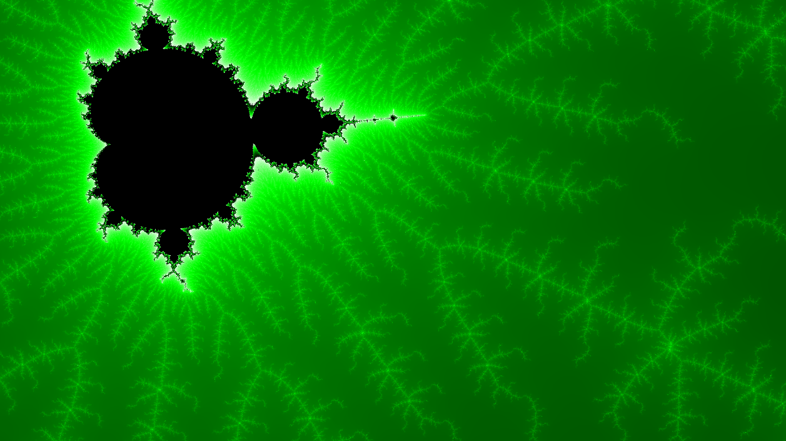

Figure 10: First render for the fixed-point implementation

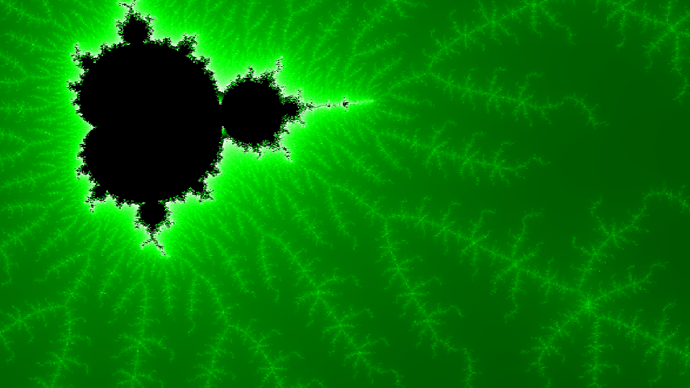

Figure 11: First render for the floating-point implementation

The second renders (figures 12 and 13) show a 100x zoom into the top left corner of the first renders. The idea is to emphasize how much the fixed-point implementation is more precise that the floating-point. It can be seen in the figures that the difference is indeed massive and that the fixed-point data type has a much higher precision.

Based on the resource usage and the precision comparison, it is clear that fixed-point data type is the way to go for this project, mainly because very few bits are required for representing the integer value and so most of the bits are used for precision. If this was not the case, the situation would probably be different.



Figure 12: Second render for the fixed-point implementation



Figure 13: Second render for the floating-point implementation

Another optimisation regarding data types is to not use all 32 bits for representing integers, since the highest values ever represented in the IP are in the range of thousands. The values are also never negative, so unsigned integers can be used. The *uint16_t* data type is used (unsigned short integer) to represent all integer values in the IP. This allows values of up to 65535, which should be well beyond any required values anywhere in the IP.

### Low-Level Optimisations

There are many low-level optimisations in the code that should be mentioned, and their impact analysed. Even moving an expression to a different line or splitting an expression across multiple lines can have great effect on the final resource usage when exporting the IP.

One of the improvements to the design is an addition of the *register* keyword to the *interface* pragma for *config* port. This registers the signal at the beginning of execution and prevents it from being changed until the IP finishes execution. This enables changing the *config* without the need to wait for the IP to finish execution, for instance if multiple frames are being rendered after each other to form a video.

Since division is generally much slower that a multiplication, especially for fixed‑point arithmetic, where multiplication takes around 8 clock cycles and division over 50, divisions by *img_width* and *img_height* inside the initialisation loop code are replaced by a multiplication with a ­*width_fraction* and *height_fraction* respectively. These two values are computed before all the loops at the top of the function. This decreases the iteration latency of the pipelined loop and reduces its hardware resource usage.

A *loop_flatten* pragma directive is added to the top of the inner-most for-loop of the maintenance loop. This allows the design to optimise out clock cycles required to move from an outer loop to an inner loop. [25]

The calculations in the initialisation code in the *maintenance* loop are split across multiple lines. This seems to enforce HLS to only process 32 bits for each calculation instead of increasing the precision when multiple calculations are performed on a single line and only limiting the precision when the variable is being stored.

Lastly, the processing performed in the *subLineProcess* function is reordered so that the square of *x* and the square of *y* does not need to be computed multiple times. They are both computed at the top of the loop and stored in a variable which then later substitutes the actual computation of the squares. Multiplications are split across multiple lines so that each line contains at most only a single multiplication. Normally the check for diverging would be performed by squaring the newly calculated values of *x* and *y*, but since the squares for the old values have already been calculated the check is performed on the old values instead. All these steps minimise the number of DSPs to a bare minimum, since the DSP usage is currently considered to be one of the main bottlenecks while parallelising the IP.

### Resulting Solution

The resulting contents of the files *Mandelbrot.h* and *Mandlebrot.cpp* can be seen in code listings 22 and 23 respectively. The content of the *Config.h* file has not been modified and can be seen in code listing 6.

Code listing 22: Content of Mandelbrot.h file after optimisation

#ifndef _MANDELBROT_H_

#define _MANDELBROT_H_

#include "Config.h"

#include "hls_video.h"

#include "ap_fixed.h"

#define PARALLEL_LOOPS         8

#define PARALLEL_SUB_LOOPS     2

#define WIDTH                  1920

#define HEIGHT                 1080

#define SUB_LOOP_WIDTH         WIDTH / PARALLEL_SUB_LOOPS

typedef hls::stream<ap_axiu<32,1,1,1>>       AXI_STREAM;

typedef hls::Scalar<3, unsigned char>        RGB_PIXEL;

typedef hls::Mat<HEIGHT, WIDTH, HLS_8UC3>    RGB_IMAGE;

typedef ap_fixed<32, 4, AP_RND, AP_SAT> fixed_32_4_SAT;

void mandelbrot(AXI_STREAM& OUTPUT_STREAM, Config& config);

void calculate(Config& config, RGB_IMAGE& img);

void subLineProcess(

fixed_32_4_SAT x_0[],

fixed_32_4_SAT y_0[],

fixed_32_4_SAT x[],

fixed_32_4_SAT y[],

uint16_t iter[],

uint16_t max_iter

);

RGB_PIXEL getPixel(uint16_t& iteration, uint16_t& max_iteration);

#endif

Code listing 23: Content of Mandelbrot.cpp file after optimisation

#include "Mandelbrot.h"

void mandelbrot(AXI_STREAM& OUTPUT_STREAM, Config& config) {

    #pragma HLS INTERFACE s_axilite register port=config

    #pragma HLS INTERFACE axis port=OUTPUT_STREAM

    #pragma HLS INTERFACE s_axilite port=return

    #pragma HLS DATAFLOW

    RGB_IMAGE img(config.img_height, config.img_width);

    calculate(config, img);

    hls::Mat2AXIvideo(img, OUTPUT_STREAM);

}

void calculate(Config& config, RGB_IMAGE& img) {

    fixed_32_4_SAT x_0[PARALLEL_LOOPS][PARALLEL_SUB_LOOPS][SUB_LOOP_WIDTH];

    #pragma HLS ARRAY_PARTITION variable=x_0 complete dim=2

    #pragma HLS array_partition variable=x_0 complete dim=1

    fixed_32_4_SAT y_0[PARALLEL_LOOPS][PARALLEL_SUB_LOOPS][SUB_LOOP_WIDTH];

    #pragma HLS array_partition variable=y_0 complete dim=2

    #pragma HLS array_partition variable=y_0 complete dim=1

    fixed_32_4_SAT x[PARALLEL_LOOPS][PARALLEL_SUB_LOOPS][SUB_LOOP_WIDTH];

    #pragma HLS array_partition variable=x complete dim=2

    #pragma HLS array_partition variable=x complete dim=1

    fixed_32_4_SAT y[PARALLEL_LOOPS][PARALLEL_SUB_LOOPS][SUB_LOOP_WIDTH];

    #pragma HLS array_partition variable=y complete dim=2

    #pragma HLS array_partition variable=y complete dim=1

    uint16_t iter[PARALLEL_LOOPS][PARALLEL_SUB_LOOPS][SUB_LOOP_WIDTH];

    #pragma HLS array_partition variable=iter complete dim=2

    #pragma HLS array_partition variable=iter complete dim=1

    uint16_t max_iter = config.max_iteration;

    uint16_t img_height = config.img_height;

    uint16_t img_width = config.img_width;

    fixed_32_4_SAT plot_height = config.plot_height;

    fixed_32_4_SAT plot_width = config.plot_width;

    fixed_32_4_SAT plot_x_min = config.plot_x_min;

    fixed_32_4_SAT plot_y_max = config.plot_y_max;

    fixed_32_4_SAT width_fraction = (fixed_32_4_SAT)1 / img_width;

    fixed_32_4_SAT height_fraction = (fixed_32_4_SAT)1 / img_height;

    for(uint16_t img_y = 0; img_y <= img_height; img_y = img_y + PARALLEL_LOOPS) {

        // '<=' used since one extra loop is needed for img.write at the end

        for(uint16_t i = 0; i < PARALLEL_LOOPS; i++){// MAINTENANCE LOOP

            uint16_t img_x_offset = 0;

            for(uint16_t j = 0; j < PARALLEL_SUB_LOOPS; j++){

                for(uint16_t sub_x = 0; sub_x < SUB_LOOP_WIDTH; sub_x++){

                    #pragma HLS LOOP_FLATTEN

                    #pragma HLS PIPELINE

                    if (img_y != 0) {// IMAGE WRITING CODE

                        // nothing to write at beginning of first loop

                        img.write(getPixel(iter[i][j][sub_x], max_iter));

                    }

                    if (img_y != img_height) {// INITIALISATION CODE

                        // nothing to initialise during the extra loop

                        uint16_t img_x = img_x_offset + sub_x;

                        fixed_32_4_SAT x_0_t1 = img_x * width_fraction;

                        fixed_32_4_SAT x_0_t2 = plot_width * x_0_t1;

                        x_0[i][j][sub_x] = plot_x_min +  x_0_t2;

                        // use current img_y pixel row number (img_y+i)

                        fixed_32_4_SAT y_0_t1 = (img_y+i) * height_fraction;

                        fixed_32_4_SAT y_0_t2 = plot_height * y_0_t1;

                        y_0[i][j][sub_x] = plot_y_max - y_0_t2;

                        x[i][j][sub_x] = 0;

                        y[i][j][sub_x] = 0;

                        iter[i][j][sub_x] = 0;

                    }

                }

                img_x_offset += SUB_LOOP_WIDTH;

            }

        }

        if (img_y != img_height) {

            // nothing to process during the extra loop

            for(uint16_t i = 0; i < PARALLEL_LOOPS; i++) {// PROCESSING LOOP

                #pragma HLS UNROLL

                for (uint16_t j = 0; j < PARALLEL_SUB_LOOPS; j++) {

                    #pragma HLS UNROLL

                    subLineProcess(

x_0[i][j],

y_0[i][j],

x[i][j],

y[i][j],

iter[i][j],

max_iter

);

                }

            }

        }

    }

}

void subLineProcess(

fixed_32_4_SAT x_0[],

fixed_32_4_SAT y_0[],

fixed_32_4_SAT x[],

fixed_32_4_SAT y[],

uint16_t iter[],

uint16_t max_iter

){

    for (uint16_t j = 0; j < max_iter; j++) {

        for (uint16_t sub_x = 0; sub_x < SUB_LOOP_WIDTH; sub_x++) {

            #pragma HLS PIPELINE

            fixed_32_4_SAT x_sq = x[sub_x]*x[sub_x];

            fixed_32_4_SAT y_sq = y[sub_x]*y[sub_x];

            fixed_32_4_SAT temp = x_sq - y_sq + x_0[sub_x];

            fixed_32_4_SAT x_y = x[sub_x]*y[sub_x];

            fixed_32_4_SAT x_y_2 = x_y * 2;

            y[sub_x] = x_y_2 + y_0[sub_x];

            x[sub_x] = temp;

            iter[sub_x] = iter[sub_x] + (x_sq + y_sq < 4);

        }

    }

}

RGB_PIXEL getPixel(uint16_t& iteration, uint16_t& max_iteration) {

    #pragma HLS INLINE

    RGB_PIXEL result;

    if (iteration < max_iteration) {

        uint16_t colour = iteration % 512;

        if (colour > 255) {

            colour = colour - 256;

            result = RGB_PIXEL(colour, 255, colour);

        } else{

            result = RGB_PIXEL(0, colour, 0);

        }

    } else {

        result = RGB_PIXEL(0,0,0);

    }

    return result;

}

### Results

The resulting render is identical to the previous render shown in figure 8. The render takes 0.92 seconds to complete, which is an incredible performance boost compared the earlier iterations. The positive effects of the optimisations are clearly evident.

## Performance Comparison

Out of all the three iterations, every single one represents an important step in the development of the final solution. It is clear that the effectiveness and performance of the design has improved throughout the project. The performance comparison of different stages of the design, including software implementation and all three iterations of the hardware implementation can be seen in figure 14. The performance of the final optimised solution truly reflects on the complex procedures undertaken to develop it. A render time of less than one second means that a user can have an interactive experience when working with the FPGA. This fact also makes it possible to consider developing a proper interactive interface for the FPGA, one which would allow the user to make the most out of the optimised solution.

Figure 14: Graph comparing render times of different implementations

# Interactive Application

A stretch goal implementation and the final design process of this project is aiming to create an interactive experience, allowing the user to zoom-in and zoom-out, change the number of iterations and modify the fractal colours, all through an easy to use interface with real‑time visual feedback. A GUI application running on a user’s PC would communicate with the PYNQ board, which would render its output onto a monitor through HDMI. The PC application itself needs to render the fractals to the user to enable the interactive zooming and potentially function on its own when an FPGA is not available. The application renderer should be at least as fast as the FPGA even if it would mean that the render quality has to be decreased initially and progressively catch up, possibly by rendering lower resolution at first, although ideally this would be avoided by producing an optimised design.

Several design decisions must be made and thus the following questions arise:

* Which programming language should be used?
* Which GUI library should be used?
* How does the application communicate with the PYNQ-Z1 board?
* How to achieve maximum performance when rendering fractals?

The programming language used to create the application will be Python 3.6, since it is already used on the PYNQ Z1 board for the main execution and the custom drivers’ source code. This should keep the codebase consistent. The library used for the GUI design will be PyQt 5.11, the latest version of a Python binding of a cross-platform C++ GUI toolkit called Qt. The communication can easily be handled through SSH, since it is already set up on the PYNQ-Z1 board and it provides full and easy access to all of its functionality. A Python library used for the connection will be Paramiko. To achieve high rendering performance, a C++ Boost Python library will be used to create a C++ library that the Python code can call to handle the calculations. The library will then use the Boost Compute library to execute a custom OpenCL kernel on a default OpenCL device available on the platform running the application, ideally a GPU. Further optimisations might be explored if the GPU renderer is not fast enough to keep up with the FPGA when running on a reference platform, which is represented by a laptop with Nvidia GeForce MX150 GPU.

## Adjustable Colours

The user needs to be able to adjust the colours produced by the IP. If the colours are defined as part of the IP configuration input, they can be accessed inside the IP and used to colour the fractal. A standard way to do this would be to define a colour map that would be used to convert an iteration value to an appropriate colour. This is not optimal with regards to the amount of data that would need to be transferred as well as to the difficulty to customise the colour map for the user. A more straight forward and efficient solution is to define a colour map as a collection of colours uniformly distributed across a colour ramp, with one extra colour for pixels that never diverge. Additionally, an offset and span can respectively be defined to specify how far from the beginning of the ramp the first colour is located and how many iterations does it take to fully interpolate from one colour to the next, or in other words how spaced out the colours on the colour ramp are. This would effectively mean that the colours would be saturated to the first colour if the number of iterations has not yet reached the colour offset value. For very high iteration values, when the last colour on the colour ramp has been reached, and there are no more colours to interpolate to, the resulting pixel would equal to that last colour. An exception to this would be if the pixel never diverges and reaches the iteration value equal to the maximum number of iterations, when the extra colour defined would be used to colour this pixel as mentioned above.

The colour offset is used to specify directly how many iterations are skipped before the first colour starts interpolating with the second colour. It defaults to zero and would be usually increased when zooming deep into the fractal to make sure that the first colour still affects the render since pixels might only start diverging at high iteration values.

The colour span defines how many bits of the resulting iteration value are used to interpolate between the colours. This is due to the way how interpolation is calculated on the IP. Effectively, the number of iterations it takes to fully interpolate between two colours is equal to 2 to the power of the colour span input value. The default value is 8, which means that it would take 256 iterations to fully interpolate between two colours. This value is chosen because 8-bit colour channels are used, so by default, if the interpolation would happen between black and white, every single iteration would increase the value of each colour channel by one, achieving a 1:1 ration. Increasing the colour span effectively divides the iteration value by 2 for each increment above the default value of 8. On the other hand, decreasing the colour span multiplies the iteration value by 2 for each decrement below the default value. The modified interpolation value is then used to select between one of the 256 different colour interpolations generated for any two colours. This enables some clever bit-wise manipulation to be implement on the IP and achieve a nice colour transition without having to perform any resource heavy operations.

The modified *Config.h* file (see Appendix A for code listing) contains seven additional unsigned integer variables with descriptive names, where *colour_4* represent the extra colour used for non-diverging pixels. The colour channels are stored inside an integer as 0xRRGGBB, where R, G and B represent red, green and blue colour channel values respectively (2 hexadecimal values per 8-bit channel). Also, all the other integers have been converted to unsinged integers to enforce consistency.

The *Mandebrot.h* file (see Appendix B for code listing) had to be modified to include the additional colour channel inputs into the *getPixel* function, which are provided as individual channels to avoid any operations that might be needed to extract them.

Lastly the *Mandelbrot.cpp* file (see Appendix C for code listing) contains additional code to extract the inputs from the *Config* struct and store them in designated variables, also extracting individual colour channels from each colour input. The *getPixel* call is then called with these additional arguments. The *getPixel* function is heavily rewritten to accommodate the code for calculating the correct pixel colour based on the description provided above. It is optimised so that only uses 3 DSPs by using separate variables defined at the top of the function to store the correct colour inputs, which are then interpolated using a single set of 3-channel interpolation code at the end of the function before the resulting pixel is returned.

## HDMI Output

The *base* overlay contains a block design to handle HDMI input and output, which is compatible with the Python drivers provided by the *pynq* library. Many of the blocks in the design are custom IPs provided along with the *base* overlay. [21] In order for the drivers to work properly with the overlay, the IP and hierarchy names and structure need to conform to the assumptions made in the drivers’ code. The easiest way to achieve this is to simply extract the whole *video* hierarchy from the *base* overlay and paste it in the existing Mandelbrot overlay design. The final overlay design is achieved by replacing the *hdmi_in* hierarchy with the Mandelbrot IP and connecting it up to clock signals and the VDMA. The whole video pipeline runs at 142Mhz and so the Mandelbrot IP needs to have a clock period of 7ns or lower, which has already been achieved. The frame count of the *axi_vdma* block is again set to 2 as in the previous iteration, leaving the rest of the configuration intact. There is no real need for a frame count higher than 1, since rendering a frame and reading it happens synchronously, but setting the frame count to 1 is not possible because it causes errors in the default drivers, so a frame count of 2 is used. The Mandelbrot IP is now contained inside a *video* hierarchy along with the *hdmi_out* hierarchy and the VDMA. The top-level overlay design can be seen in Appendix D. It is similar to the previous design shown in figure 9, but the *video* hierarchy now contains all the IPs related to handling output processing. The top-level design also contains the ZYNQ7 Processing System, System Reset blocks for both the 100Mhz and 142Mhz clock signals, the Interrupt Controller and an AXI Interconnect block connecting up the ZYNQ7 Processing System to the Interrupt Controller and the *video* hierarchy. Additionally, 3 outputs for the HDMI I/O have been defined. The constraints, specifying the appropriate pins for HDMI output, were specified in a new constraints file. Its contents can be seen in Appendix H.

The *video* hierarchy design with all of its inputs/outputs can be seen in Appendix E. Its main components are the Mandelbrot IP, AXI VDMA and the *hdmi_out* hierarchy. The Mandelbrot IP outputs its pixel stream into the Axi VDMA’s write channel (S2MM) which then outputs it’s read channel (MM2S) to the *hdmi_out* hierarchy. There are two AXI Interconnect blocks present. The *axi_mem_intercon* is connecting the AXI VDMA memory (clock speed of 142MHz) to the hierarchy output which is then connected to the ZYNQ7 Processing System block. The *axi_interconnect­­_0* is connecting up all the AXI-Lite interfaces at their appropriate clock speeds (determined by the IP’s clock period) to the hierarchy input which is then also connected to the ZYNQ7 Processing System block. Lastly, a Concat block is used to concatenate all the interrupts before outputting them to the hierarchy output. The clock and reset inputs are connected to their appropriate block inputs.

The block design of the *hdmi_out* hierarchy has been left unchanged and can be seen in Appendix F. Its *frontend* hierarchy design can be seen in Appendix G and was also left unchanged. This means that they are both identical to their respective designs in the current version of the *base* overlay and are listed here merely as a curiosity.

## Drivers and Python Scripts on the PYNQ-Z1

A Jupyter notebook can no longer be used to execute the Python scripts and initialise the drivers on the PYNQ-Z1 board, because the code needs to be contained in native Python files so that it can be executed from an SSH shell. This is a good opportunity to refactor the design into individual modules and separate drivers from the rest of the code, keeping everything in separate files. The code is thus split into 4 parts:

* Mandelbrot driver (see Appendix I for code listing)
  + Handles communication with the Mandelbrot IP
  + Abstracts implementation details (such as register addresses) behind an interface with user-friendly and self-explanatory function names
* AxiVDMA custom driver (see Appendix J for code listing)
  + Extends the provided AxiVDMA driver to override the frame count
* Renderer class (see Appendix K for code listing)
  + Contains methods for dealing with the main rendering functionality
  + Handles different types of rendering (to HDMI, to PIL Image, etc.)
  + Provides a *close* method used for cleaning up before shutdown
* HDMI script (see Appendix L for code listing)
  + Sets up system paths for importing and then imports everything
  + Loads an overlay and initialises all the drivers and the Renderer class

With all these files on the PYNQ-Z1 board, in order to set up the overlay, drivers and the Renderer, the user only needs to import the required objects from the HDMI script (at least the instance of the Renderer class called *renderer*, but probably also the instance of Mandelbrot driver class called *mandelbrot*, or simply everything) to make them available for interaction. An important point is to make sure to call the *close* method of the *renderer* before shutdown to free DMA memory and stop the HDMI drivers to avoid any undefined behaviour during subsequent initialisations.

## C++ Accelerators

A Python dynamically linked library file called *Mandelbrot.pyd*, which is compiled from a single C++ source file, is used to accelerate the fractal rendering. It contains a *Mandelbrot* Python module thatcan be imported by the application. This interoperability between Python and C++ is facilitated by the Boost Python framework. which also provides data type definitions that can be used by both C++ and Python code. Code listing of the C++ source code can be seen in Appendix M.

A single *calculate* function is defined and exported. A NumPy *ndarray* is used as a return type, containing the image data. The function itself accepts a complete render configuration as its arguments and returns the resulting image data. It further uses a Boost Compute library to execute OpenCL kernels on the underlying platform.

When the function is invoked it gets the system’s default OpenCL device, compiles an OpenCL program for the device (unless it can be retrieved from cache) and enqueues a kernel with appropriate arguments. The kernel’s source code is provided as a constant character array and very closely resembles the source code used to synthesize the Mandelbrot IP, but with built-in OpenCL data types (double precision floating point data type is used to provide extra zooming capabilities) and without pragma directives and other HLS optimisations. Each kernel calculates colour channels of a single pixel and writes them into the appropriate location of the device vector provided. The solution is not very optimised, as that is beyond the scope of this project. Additionally, some warp divergence is present due to the high number of branching. Despite all this, the solution performs very well even on an entry level GPU (Nvidia GeForce MX150), where, at default render configuration, an average observed render time is about 0.4 seconds. The render time varies a lot based on the render configuration, which means that the slowest observed render took 0.64 seconds and the fastest observed render took only 0.21 seconds to compute.

Some solution specific configuration is required to successfully compile the source code using Visual Studio 2018. The required C++ and Python libraries need to be made available to the compiler as well as the linker. Also, the output file needs to be set to have a *.pyd* extension so that it can be imported by Python code later on. Additionally, based on the hardware of the device the application is running on, a parallel computing platform API that supports OpenCL, such as CUDA, needs to be installed on the device and its libraries included in the project configuration. With all the dependencies in place, the source code can be compiled to create the resulting library file targeted for a desired platform. The solution analysed in this chapter has been built with x64 architecture settings, although x86 should produce similar results in terms of usability and performance.

## Desktop Graphical User Interface

As mentioned above, the GUI for the Python application running on a PC is created with PyQt. The design of the application is relatively straight forward and follows the MVC (model, view, controller) pattern. The application consists of 4 main parts:

* Model (see Appendix N for code listing)
  + Encapsulates the application state and rendering functionality
  + Uses the compiled C++ code to accelerate local fractal rendering
  + Forwards configuration and render commands to PYNQ-Z1 over SSH
* View (see Appendix O for code listing)
  + Initialises all the PyQt GUI elements inside a main window
  + Provides methods for the controller to interact with the view, while keeping the controller decoupled from the PyQt framework
* Controller (see Appendix P for code listing)
  + Controls the application flow and modifies the view and the model
  + Registers its user event handlers with elements inside the view
  + Sets up an interactive SSH shell connection to the PYNQ-Z1 board
* Main execution script (see Appendix Q for code listing)
  + Initialises model, view and controller, which sets off the execution

The application initially asks the user whether an SSH connection should be established with the PYNQ-Z1 board. If that is the case, the user is prompted to input a hostname of the device and its access credentials in form of a username and a password. These are then used to connect to the device and set up an interactive SSH shell session with admin privileges, invoke a Python terminal on the device and set up a Python environment that can accept commands from the model. If the user decides to not connect to the device, the shell is not instantiated, and the application simply skips any shell invocations throughout the course of its execution.

Once the setup is complete and all event handlers have been registered, the application renders the initial default fractal and passes the execution control onto the GUI, which simply reacts to any user events invoked during the interaction. The GUI is comprised of a QLabel, which contains the currently rendered fractal, and an array of control input elements contained inside a QBoxLayout aligned to the top of the render view. There are three QSpinBox spinner inputs for numbers and six QPushButton buttons, contained inside the QBoxLayout from left to right respectively:

* Maximum number of iterations
* Colour offset
* Colour span
* Save
* Colour 0
* Colour 1
* Colour 2
* Colour 3
* Colour 4

These values are used to modify the render configuration, except the *save* button, which is used to save the currently rendered fractal as a PNG image. The numeric inputs have appropriate limitation assigned to them in order to prevent values unsupported by the Mandelbrot IP to be inputted. The *save* button is a standard button without any modifications. The colour buttons are flat buttons coloured to match the current value of the colour they represent. If a colour button is pressed, the user is presented with a QColorDialog window so that a new colour can be selected. If the QColorDialog is cancelled, the colour remains unchanged.

The user can further interact with the GUI by performing one of the following:

* Left mouse button click to zoom-in, centred at the click location
* Left mouse button press and drag to select an area to zoom into
* Right mouse button click to zoom-out, centred at the click location

The main functionality of the application, the rendering, is contained inside the model class. It holds the rendering configuration and exposes a range of getters and setters to modify it. If an SSH shell session is set up, the model forwards any configuration changes to the PYNQ-Z1 board. To carry out the actual rendering, the model sends an appropriate command to the PYNQ-Z1 board (if connected), and then invokes the C++ accelerator module to compute the fractal render, supplying all the render configuration. Once completed, the resulting image is displayed.

## Results

A screenshot of the initial state of the application can be seen in figure 15. If the user opted to connect to a PYNQ-Z1 board and inputted the correct domain, username and password values into the command prompt, the application should successfully connect to the board, initialise the Python environment, load the overlay, and render the initial fractal configuration. Afterwards, all the actions carried out in the GUI application should be reflected by the PYNQ-Z1 board output.

The controls allow the user to interactively customise the render configuration with relative ease. A screenshot of a GUI state after some arbitrary user interaction can be seen in figure 16. In this case the zoom is quite extensive, so the maximum number of iterations has been increased to 2000. The colour offset has been increased to 400 to make sure that the first colour still affects the render, even if the number of iterations for all the pixels in the render is relatively high. The colour span has been decreased to 7 from its default value of 8 in order to make the colours interpolate faster and achieve more prominent colour changes. Subjectively interesting colours have been selected to provide a render that is pleasing to the eye, while still achieving a high contrast between neighbouring colours, ensuring that the shapes generated by the fractal are well visible. Colour 4 (extra colour for non-diverging pixels) has been selected to be identical to colour 3 in order to hide the non-diverging pixels, which would otherwise disrupt the smooth transitions present in the render.

The responsiveness of the GUI makes it easy to fine-tune the configuration to achieve interesting results. Some examples of such render results, that have been saved using the save button functionality, can be seen in Appendix R. The resulting application successfully fulfils the outlined goals and provides a fast and independent fractal renderer, that can be used to interact with the PYNQ-Z1 board and the FPGA.

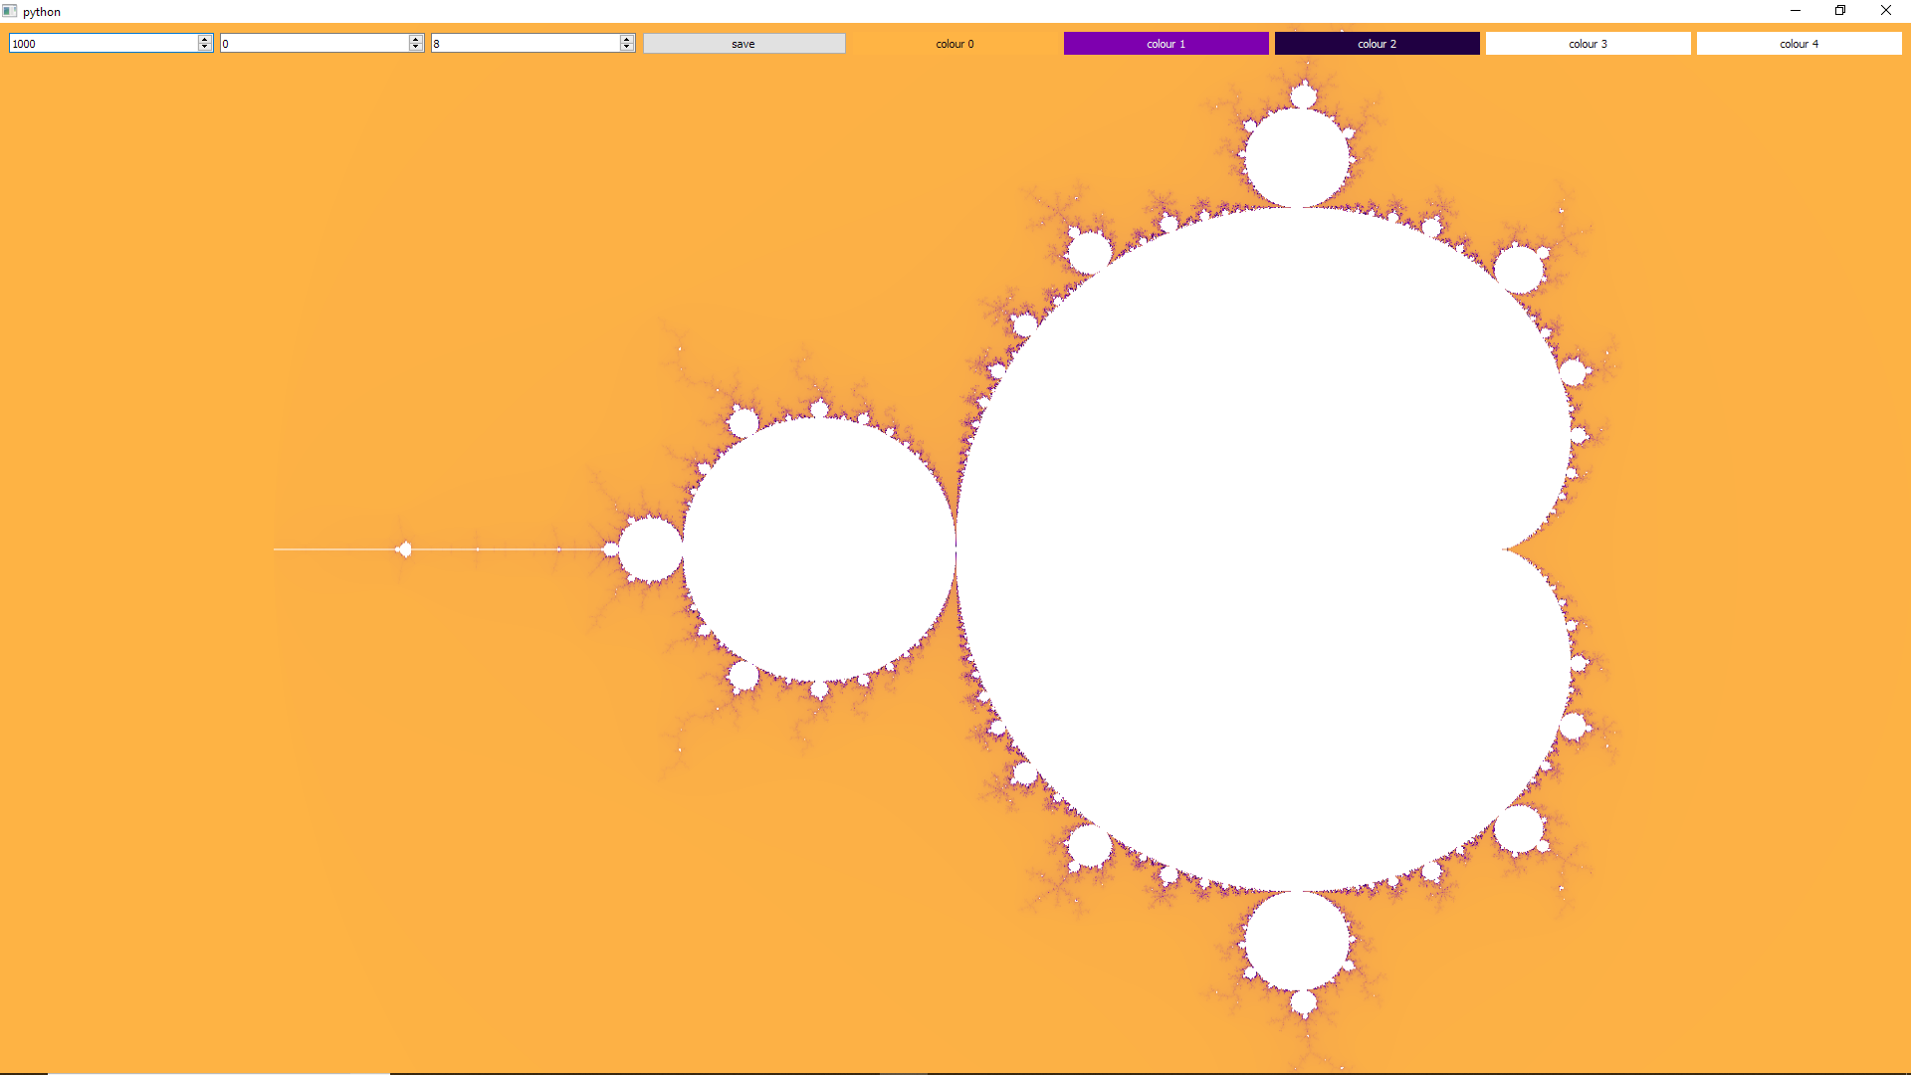

Figure 15: Initial state of the GUI

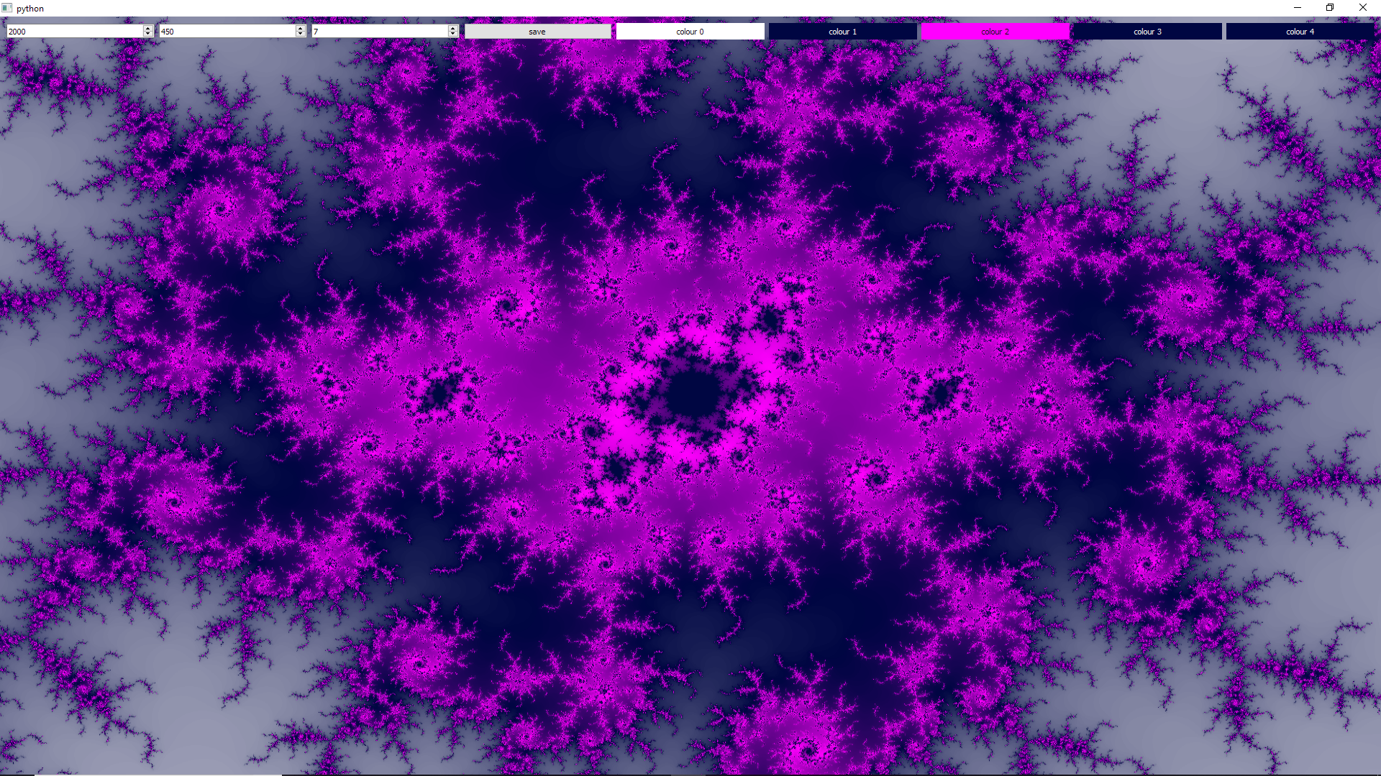

Figure 16: Example of a GUI state after user interaction

# Summary of Results

All the key objectives were accomplished during the course of this project. After conducting research into fractals, and selecting a Mandelbrot set to be the fractal this project will focus on, a software implementation was developed, running both on a regular desktop computer with Python environment, as well as the PYNQ-Z1 board once it was properly set-up. This was then used as a starting point for developing an IP for calculating the Mandelbrot set on the FPGA. Firstly, an IP was developed, which could only calculate individual pixel values based on given input. This was later transformed into an IP that would output full images for given inputs into VDMA, which could later be retrieved and displayed to the user, effectively providing a full rendering solution running on an FPGA. At this point the renders were configured and retrieved through a Jupyter notebook and a single render with 1000 iterations would take about 227.6 seconds to complete.

Additionally, two stretch goals were implemented. The IP has undergone an extensive, hardware specific optimisation to achieve more than 200 times higher render performance compared to the unoptimized design. Its functionality was also extended later on by adding inputs to modify the colours and their effects on the render. A Python desktop application was developed with interactive GUI and standalone fractal rendering capabilities, which could connect a PYNQ-Z1 board through SSH and allow a user to interact with the FPGA in a friendly fashion. The standalone renderer was developed in C++ and uses an OpenCL framework to achieve a very high rendering performance by executing the code on OpenCL platforms, such as multicore CPUs or (ideally) GPGPUs.

# Discussion

It can be seen that the development process for FPGAs is a relatively lengthy and complex task. Even though simulations can be performed on the source code and the analysis report during synthesis and implementation phase of the overlay design are very helpful, bugs in the design can manifest at later stages, possibly only when the overlay is loaded onto the FPGA and the design produces unexpected results. The reason this poses an issue is due to the fact that the bitstream generation takes upward of half an hour to complete even on modern high-end hardware. This can slow down the design process tremendously. Furthermore, the performance of the final solution is very sensitive to optimisation, as can be seen in the Performance Comparison part of the report. The solution translates to a physical circuit, not machine code stored in memory, so the size of the program needs to be closely monitored, which is something that is not really an issue for standard programming techniques. High-level synthesis closely resembles OpenCL kernel programming, but the number of non-standard rules and features and the addition of pragmas, which are simply part of the editor, makes it very difficult for a programmer to get started. This is further hindered by unfriendly documentation delivery in form of massive PDF documents, that make it very difficult to extract useful information without extensive search, compared to for example the PyQt documentation that was extensively used during the development in the Interactive Application section of the report, which provides a user friendly online portal containing very detailed description of all parts of the API with links and references to quickly jump between definitions. This comparison is necessary to understand the major flaws in FPGA design process as of today, where the question of development expenses plays an important role in deciding which technology should be used for given project.

If the goal is to achieve high parallel performance, when compared to GPGPUs the FPGA suffers from the lengthy development and testing difficulty issues. Even though during testing the OpenCL implementation came on top with regards to performance, it is important to note that the price/performance ratio between GPGPUs and FPGAs would be a more suitable component used for the comparison. If FPGAs could be for instance integrated into modern desktop computers to accelerate performance heavy tasks, software could be shipped with overlays or IPs that could be loaded onto the FPGA if the software is in use to provide a flexible hardware acceleration. In this sense, the PYNQ framework is the step in the right direction, providing a healthy abstraction layer between the processor and an FPGA, even though the framework is still very young and underdeveloped, with fragile libraries and sparse documentation, where developers often need to read through the library source code to understand a source of an error or unexpected behaviour.

All in all, despite all complication the final design was developed, presenting a relatively polished product that could be used both to explore the Mandelbrot set and to serve as a design reference for other engineers. The resulting renders that can be achieved with right configuration are very intriguing, simply because of the infinitely detailed nature of the Mandelbrot set. Fractal rendering represents a relatively well‑documented problem that can be used to measure system performance and its capabilities, while also producing an output, which due to its nature can never get repetitive or uninteresting.

# Conclusion

The project has shown a successful design process of developing a fractal renderer on an FPGA using the PYNQ framework. Additionally, it has managed to draw conclusions from the differences between alternative design approaches and the capabilities, advantages and disadvantages of FPGAs as means to accelerate an algorithm using digital hardware design. The final solution, consisting of an FPGA overlay design, its Python drivers and an independent desktop application that can be used to interact with the FPGA over network connection, represents the product of this project.

The rather extensive length of this report is a product of the additional stretch goals accomplished as well as their complexity. The Mandelbrot set has provided an ideal algorithm to work with, both simple in nature and complex in its results. This has allowed it to be fully analysed, optimised and explored. The renders produced using the final solution conclude the technical aspect of the overall design process with a touch of abstract art.

# Appendices

1. Config.h

#ifndef _CONFIG_H_

#define _CONFIG_H_

struct Config {

unsigned int img_width;

unsigned int img_height;

double plot_width;

double plot_height;

double plot_x_min;

double plot_y_max;

unsigned int max_iteration;

unsigned int colour_offset;

unsigned int colour_span;

unsigned int colour_0;

unsigned int colour_1;

unsigned int colour_2;

unsigned int colour_3;

unsigned int colour_4;

};

#endif

1. Mandelbrot.h

#ifndef _MANDELBROT_H_

#define _MANDELBROT_H_

#include "Config.h"

#include "hls_video.h"

#include "ap_fixed.h"

#define PARALLEL_LOOPS 8

#define PARALLEL_SUB_LOOPS 2

#define WIDTH 1920

#define HEIGHT 1080

#define SUB_LOOP_WIDTH WIDTH / PARALLEL_SUB_LOOPS

typedef unsigned char uchar;

typedef hls::stream<ap_axiu<32,1,1,1> > AXI_STREAM;

typedef hls::Scalar<3, uchar> RGB_PIXEL;

typedef hls::Mat<HEIGHT, WIDTH, HLS_8UC3> RGB_IMAGE;

typedef ap_fixed<32, 4, AP_RND, AP_SAT> fixed_32_4_SAT;

void mandelbrot(AXI_STREAM& OUTPUT_STREAM, Config& config);

void calculate(Config& config, RGB_IMAGE& img);

void subLineProcess(

fixed_32_4_SAT x_0[],

fixed_32_4_SAT y_0[],

fixed_32_4_SAT x[],

fixed_32_4_SAT y[],

uint16_t iter[],

uint16_t max_iter

);

RGB_PIXEL getPixel(

uint16_t& iteration,

uint16_t& max_iteration,

uint16_t& colour_offset,

uchar& colour_span,

uchar& colour_0_r,

uchar& colour_0_g,

uchar& colour_0_b,

uchar& colour_1_r,

uchar& colour_1_g,

uchar& colour_1_b,

uchar& colour_2_r,

uchar& colour_2_g,

uchar& colour_2_b,

uchar& colour_3_r,

uchar& colour_3_g,

uchar& colour_3_b,

uchar& colour_4_r,

uchar& colour_4_g,

uchar& colour_4_b

);

#endif

1. Mandelbrot.cpp

#include "Mandelbrot.h"

void mandelbrot(AXI_STREAM& OUTPUT_STREAM, Config& config) {

#pragma HLS INTERFACE s_axilite register port=config

#pragma HLS INTERFACE axis port=OUTPUT_STREAM

#pragma HLS INTERFACE s_axilite port=return

#pragma HLS DATAFLOW

RGB_IMAGE img(config.img_height, config.img_width);

calculate(config, img);

hls::Mat2AXIvideo(img, OUTPUT_STREAM);

}

void calculate(Config& config, RGB_IMAGE& img) {

fixed_32_4_SAT x_0[PARALLEL_LOOPS][PARALLEL_SUB_LOOPS][SUB_LOOP_WIDTH];

#pragma HLS ARRAY_PARTITION variable=x_0 complete dim=2

#pragma HLS array_partition variable=x_0 complete dim=1

fixed_32_4_SAT y_0[PARALLEL_LOOPS][PARALLEL_SUB_LOOPS][SUB_LOOP_WIDTH];

#pragma HLS array_partition variable=y_0 complete dim=2

#pragma HLS array_partition variable=y_0 complete dim=1

fixed_32_4_SAT x[PARALLEL_LOOPS][PARALLEL_SUB_LOOPS][SUB_LOOP_WIDTH];

#pragma HLS array_partition variable=x complete dim=2

#pragma HLS array_partition variable=x complete dim=1

fixed_32_4_SAT y[PARALLEL_LOOPS][PARALLEL_SUB_LOOPS][SUB_LOOP_WIDTH];

#pragma HLS array_partition variable=y complete dim=2

#pragma HLS array_partition variable=y complete dim=1

uint16_t iter[PARALLEL_LOOPS][PARALLEL_SUB_LOOPS][SUB_LOOP_WIDTH];

#pragma HLS array_partition variable=iter complete dim=2

#pragma HLS array_partition variable=iter complete dim=1

uint16_t max_iter = config.max_iteration;

uint16_t img_height = config.img_height;

uint16_t img_width = config.img_width;

fixed_32_4_SAT plot_height = config.plot_height;

fixed_32_4_SAT plot_width = config.plot_width;

fixed_32_4_SAT plot_x_min = config.plot_x_min;

fixed_32_4_SAT plot_y_max = config.plot_y_max;

fixed_32_4_SAT width_fraction = (fixed_32_4_SAT)1 / img_width;

fixed_32_4_SAT height_fraction = (fixed_32_4_SAT)1 / img_height;

uint16_t colour_offset = config.colour_offset;

uchar colour_span = config.colour_span;

uchar colour_0_r = config.colour_0 >> 16;

uchar colour_0_g = config.colour_0 >> 8;

uchar colour_0_b = config.colour_0;

uchar colour_1_r = config.colour_1 >> 16;

uchar colour_1_g = config.colour_1 >> 8;

uchar colour_1_b = config.colour_1;

uchar colour_2_r = config.colour_2 >> 16;

uchar colour_2_g = config.colour_2 >> 8;

uchar colour_2_b = config.colour_2;

uchar colour_3_r = config.colour_3 >> 16;

uchar colour_3_g = config.colour_3 >> 8;

uchar colour_3_b = config.colour_3;

uchar colour_4_r = config.colour_4 >> 16;

uchar colour_4_g = config.colour_4 >> 8;

uchar colour_4_b = config.colour_4;

for(uint16_t img_y = 0; img_y <= img_height; img_y = img_y + PARALLEL_LOOPS) {

// '<=' used since one extra loop is needed for img.write at the end

for(uint16_t i = 0; i < PARALLEL_LOOPS; i++){// MAINTENANCE LOOP

uint16_t img_x_offset = 0;

for(uint16_t j = 0; j < PARALLEL_SUB_LOOPS; j++){

for(uint16_t sub_x = 0; sub_x < SUB_LOOP_WIDTH; sub_x++){

#pragma HLS LOOP_FLATTEN

#pragma HLS PIPELINE

if (img_y != 0) {// IMAGE WRITING CODE

// nothing to write at beginning of first loop

img.write(getPixel(

iter[i][j][sub_x],

max_iter,

colour_offset,

colour_span,

colour_0_r,

colour_0_g,

colour_0_b,

colour_1_r,

colour_1_g,

colour_1_b,

colour_2_r,

colour_2_g,

colour_2_b,

colour_3_r,

colour_3_g,

colour_3_b,

colour_4_r,

colour_4_g,

colour_4_b

));

}

if (img_y != img_height) {// INITIALISATION CODE

// nothing to initialise during the extra loop

uint16_t img_x = img_x_offset + sub_x;

fixed_32_4_SAT x_0_t1 = img_x * width_fraction;

fixed_32_4_SAT x_0_t2 = plot_width * x_0_t1;

x_0[i][j][sub_x] = plot_x_min + x_0_t2;

// use current img_y pixel row number (img_y+i)

fixed_32_4_SAT y_0_t1 = (img_y+i) * height_fraction;

fixed_32_4_SAT y_0_t2 = plot_height * y_0_t1;

y_0[i][j][sub_x] = plot_y_max - y_0_t2;

x[i][j][sub_x] = 0;

y[i][j][sub_x] = 0;

iter[i][j][sub_x] = 0;

}

}

img_x_offset += SUB_LOOP_WIDTH;

}

}

if (img_y != img_height) {

// nothing to process during the extra loop

for(uint16_t i = 0; i < PARALLEL_LOOPS; i++) {// PROCESSING LOOP

#pragma HLS UNROLL

for (uint16_t j = 0; j < PARALLEL_SUB_LOOPS; j++) {

#pragma HLS UNROLL

subLineProcess(

x_0[i][j],

y_0[i][j],

x[i][j],

y[i][j],

iter[i][j],

max_iter

);

}

}

}

}

}

void subLineProcess(

fixed_32_4_SAT x_0[],

fixed_32_4_SAT y_0[],

fixed_32_4_SAT x[],

fixed_32_4_SAT y[],

uint16_t iter[],

uint16_t max_iter

){

for (int j = 0; j < max_iter; j++) {

for (uint16_t sub_x = 0; sub_x < SUB_LOOP_WIDTH; sub_x++) {

#pragma HLS PIPELINE

fixed_32_4_SAT x_sq = x[sub_x]*x[sub_x];

fixed_32_4_SAT y_sq = y[sub_x]*y[sub_x];

fixed_32_4_SAT temp = x_sq - y_sq + x_0[sub_x];

fixed_32_4_SAT x_y = x[sub_x]*y[sub_x];

fixed_32_4_SAT x_y_2 = x_y * 2;

y[sub_x] = x_y_2 + y_0[sub_x];

x[sub_x] = temp;

iter[sub_x] = iter[sub_x] + (x_sq + y_sq < 4);

}

}

}

RGB_PIXEL getPixel(

uint16_t& iteration,

uint16_t& max_iteration,

uint16_t& colour_offset,

uchar& colour_span,

uchar& colour_0_r,

uchar& colour_0_g,

uchar& colour_0_b,

uchar& colour_1_r,

uchar& colour_1_g,

uchar& colour_1_b,

uchar& colour_2_r,

uchar& colour_2_g,

uchar& colour_2_b,

uchar& colour_3_r,

uchar& colour_3_g,

uchar& colour_3_b,

uchar& colour_4_r,

uchar& colour_4_g,

uchar& colour_4_b

) {

#pragma HLS INLINE

uchar intensity = 0;

uchar colour_a_r = 0;

uchar colour_a_g = 0;

uchar colour_a_b = 0;

uchar colour_b_r = 0;

uchar colour_b_g = 0;

uchar colour_b_b = 0;

if (iteration < max_iteration) {

iteration = iteration < colour_offset ? 0 : iteration - colour_offset;

if (colour_span < 8) {

iteration = iteration << (8 - colour_span);

} else {

iteration = iteration >> (colour_span - 8);

}

intensity = iteration;

if (iteration < 256) {

colour_a_r = colour_0_r;

colour_a_g = colour_0_g;

colour_a_b = colour_0_b;

colour_b_r = colour_1_r;

colour_b_g = colour_1_g;

colour_b_b = colour_1_b;

} else if (iteration < 512){

colour_a_r = colour_1_r;

colour_a_g = colour_1_g;

colour_a_b = colour_1_b;

colour_b_r = colour_2_r;

colour_b_g = colour_2_g;

colour_b_b = colour_2_b;

} else if (iteration < 768){

colour_a_r = colour_2_r;

colour_a_g = colour_2_g;

colour_a_b = colour_2_b;

colour_b_r = colour_3_r;

colour_b_g = colour_3_g;

colour_b_b = colour_3_b;

} else {

colour_a_r = colour_3_r;

colour_a_g = colour_3_g;

colour_a_b = colour_3_b;

colour_b_r = colour_3_r;

colour_b_g = colour_3_g;

colour_b_b = colour_3_b;

}

} else {

colour_a_r = colour_4_r;

colour_a_g = colour_4_g;

colour_a_b = colour_4_b;

colour_b_r = colour_4_r;

colour_b_g = colour_4_g;

colour_b_b = colour_4_b;

}

uint8_t r = colour_a_r + (((colour_b_r - colour_a_r) * intensity) >> 8);

uint8_t g = colour_a_g + (((colour_b_g - colour_a_g) * intensity) >> 8);

uint8_t b = colour_a_b + (((colour_b_b - colour_a_b) * intensity) >> 8);

return RGB_PIXEL(r, g, b);

}

1. Top-level overlay design

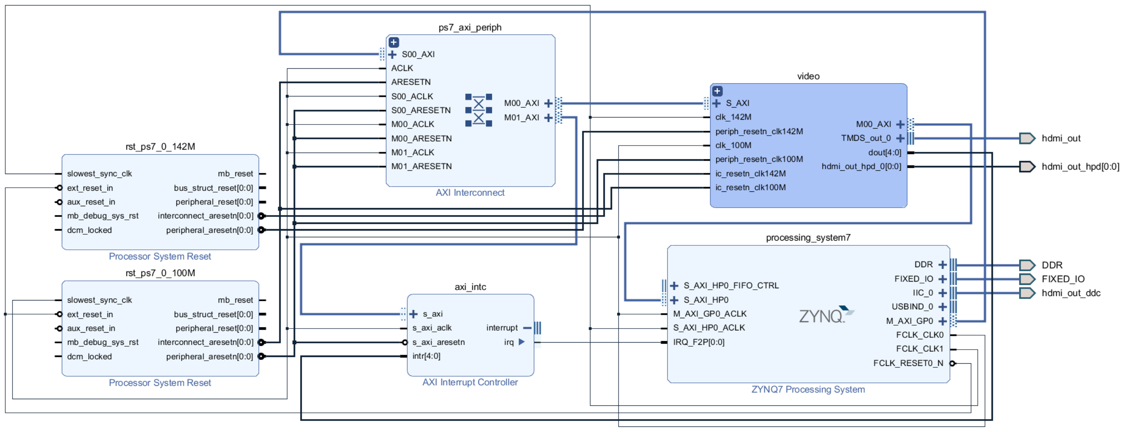

1. Block design of the video hierarchy

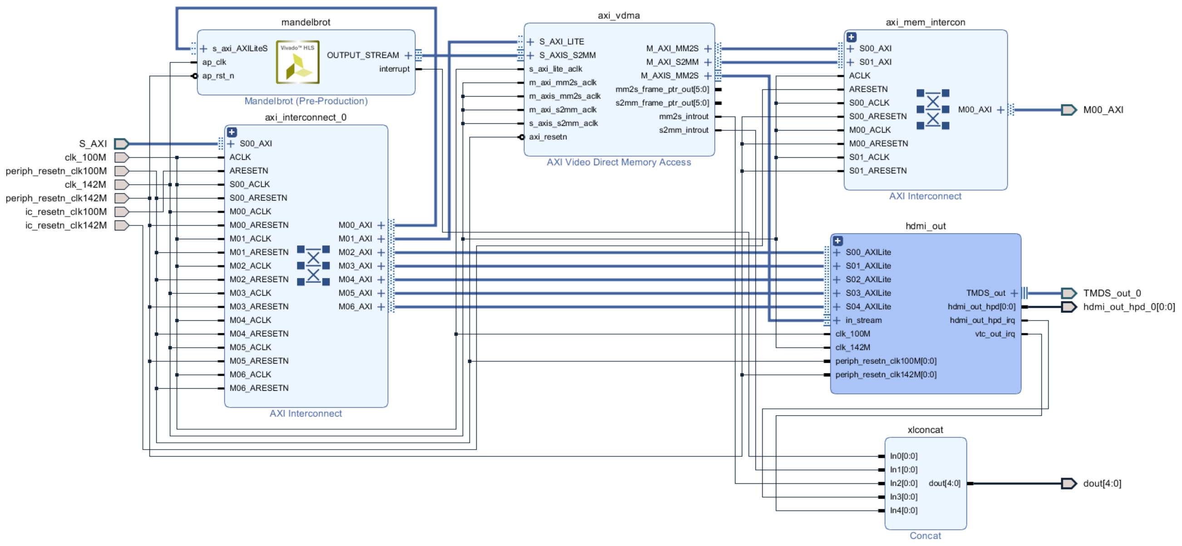

1. Block design of the hdmi_out hierarchy

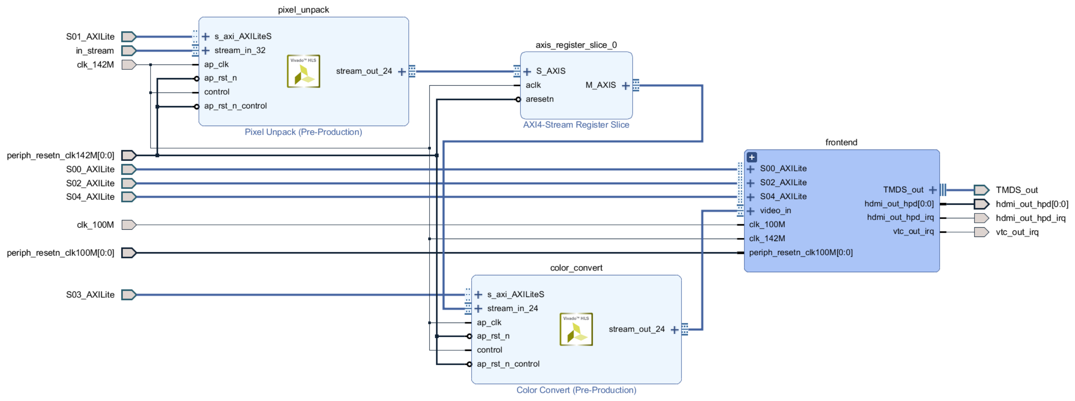

1. Block design of the frontend hierarchy

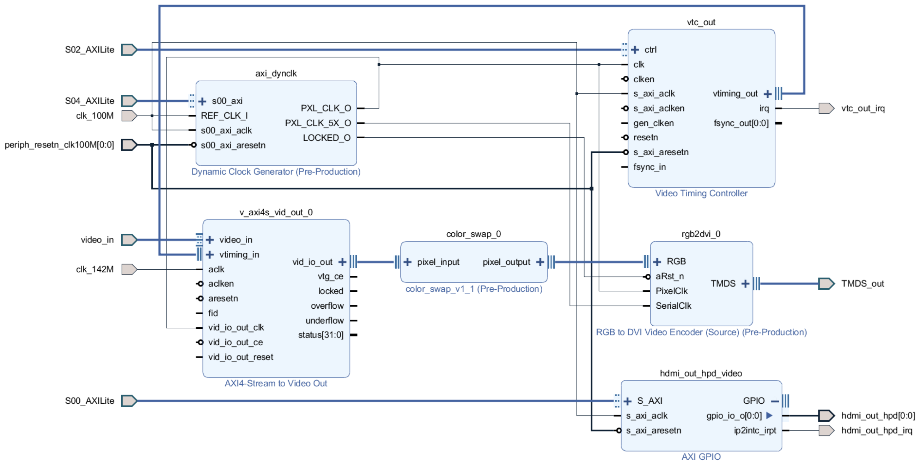

1. Constraints file for HDMI outputs

# HDMI Signals

set_property -dict {

PACKAGE_PIN L17 IOSTANDARD TMDS_33} [get_ports hdmi_out_clk_n]

set_property -dict {

PACKAGE_PIN L16 IOSTANDARD TMDS_33} [get_ports hdmi_out_clk_p]

set_property -dict {

PACKAGE_PIN K18 IOSTANDARD TMDS_33} [get_ports {hdmi_out_data_n[0]}]

set_property -dict {

PACKAGE_PIN K17 IOSTANDARD TMDS_33} [get_ports {hdmi_out_data_p[0]}]

set_property -dict {

PACKAGE_PIN J19 IOSTANDARD TMDS_33} [get_ports {hdmi_out_data_n[1]}]

set_property -dict {

PACKAGE_PIN K19 IOSTANDARD TMDS_33} [get_ports {hdmi_out_data_p[1]}]

set_property -dict {

PACKAGE_PIN H18 IOSTANDARD TMDS_33} [get_ports {hdmi_out_data_n[2]}]

set_property -dict {

PACKAGE_PIN J18 IOSTANDARD TMDS_33} [get_ports {hdmi_out_data_p[2]}]

set_property -dict {

PACKAGE_PIN R19 IOSTANDARD LVCMOS33} [get_ports {hdmi_out_hpd[0]}]

set_property -dict {

PACKAGE_PIN M17 IOSTANDARD LVCMOS33} [get_ports hdmi_out_ddc_scl_io]

set_property -dict {

PACKAGE_PIN M18 IOSTANDARD LVCMOS33} [get_ports hdmi_out_ddc_sda_io]

1. Mandelbrot.py

from pynq import DefaultIP

import asyncio

import struct

class Mandelbrot(DefaultIP):

def __init__(self, description):

super().__init__(description=description)

# Set up resolution

self.write(0x10,1920)

self.write(0x18,1080)

# Enable interrupts for ap_done

self.write(0x04,1)

self.write(0x08,1)

# Setup default config

self.set_plot_width(3.5)

self.set_plot_height(2.0)

self.set_plot_x_min(-2.5)

self.set_plot_y_max(1.0)

self.set_max_iteration(1000)

self.set_colour_offset(0)

self.set_colour_span(8)

self.set_colour_0(0xFFFFFF)

self.set_colour_1(0x888888)

self.set_colour_2(0x000000)

self.set_colour_3(0xFFFFFF)

self.set_colour_4(0xFFFFFF)

bindto = ['xilinx.com:hls:mandelbrot:1.0']

def set_plot_width(self, plot_width):

self.write(0x20,struct.pack('d', plot_width))

def set_plot_height(self, plot_height):

self.write(0x2c,struct.pack('d', plot_height))

def set_plot_x_min(self, plot_x_min):

self.write(0x38,struct.pack('d', plot_x_min))

def set_plot_y_max(self, plot_y_max):

self.write(0x44,struct.pack('d', plot_y_max))

def set_max_iteration(self, max_iteration):

self.write(0x50,max_iteration)

def set_colour_offset(self, colour_offset):

self.write(0x58,colour_offset)

def set_colour_span(self, colour_span):

self.write(0x60,colour_span)

def set_colour_0(self, colour_0):

self.write(0x68,colour_0)

def set_colour_1(self, colour_1):

self.write(0x70,colour_1)

def set_colour_2(self, colour_2):

self.write(0x78,colour_2)

def set_colour_3(self, colour_3):

self.write(0x80,colour_3)

def set_colour_4(self, colour_4):

self.write(0x88,colour_4)

def calculate(self):

# Start IP

self.write(0x00,1)

# Wait for interrupt

loop = asyncio.get_event_loop()

while(self.read(0x0c) & 0x1 == 0):

loop.run_until_complete(asyncio.ensure_future(self.interrupt.wait()))

# Clear interrupt

self.write(0x0c, 0x1)

self.interrupt.event.clear()

1. AxiVDMA_Custom.py

from pynq.lib.video import *

class AxiVDMA_Custom(pynq.lib.video.dma.AxiVDMA):

def __init__(self, description):

super().__init__(description=description, framecount=2)

bindto = ['xilinx.com:ip:axi_vdma:6.3']

1. Renderer.py

import time

import PIL.Image

class Renderer:

def __init__(self, mandelbrot, vdma, hdmi_out):

self.mandelbrot = mandelbrot

self.vdma = vdma

self.hdmi_out = hdmi_out

def get_active_frame(self):

activeframe = self.vdma.readchannel.activeframe

return self.vdma.readchannel._frames[activeframe]

def render_to_image(self):

self.mandelbrot.calculate()

# Get output

frame = self.get_active_frame()

return PIL.Image.fromarray(frame)

def timed_render_to_image(self):

start = time.time()

image = self.render_to_image()

end = time.time()

print("Render took:", end - start, "s")

return image

def render_to_hdmi(self):

self.mandelbrot.calculate()

# Stream to HDMI

frame = self.get_active_frame()

self.hdmi_out.writeframe(frame)

def close(self):

self.vdma.writechannel.stop()

self.vdma.readchannel.stop()

self.hdmi_out.close()

1. HDMI.py

import sys

sys.path.append("/home/xilinx/RenderingFractalsOnPYNQ-Z1/python/drivers")

sys.path.append("/home/xilinx/RenderingFractalsOnPYNQ-Z1/python/scripts")

import Mandelbrot

import AxiVDMA_Custom

from Renderer import Renderer

from pynq.lib.video import *

from pynq import Overlay

overlay = Overlay('/home/xilinx/pynq/overlays/personal/Mandelbrot/Mandelbrot.bit')

mandelbrot = overlay.video.mandelbrot

vdma = overlay.video.axi_vdma

hdmi_out = overlay.video.hdmi_out

hdmi_out._vdma = vdma #Quickfix

vdma.readchannel.mode = common.VideoMode(1920, 1080, 32)

hdmi_out.configure(common.VideoMode(1920, 1080, 32))

vdma.readchannel.start()

hdmi_out.start()

renderer = Renderer(mandelbrot, vdma, hdmi_out)

import time

from python.application.model.Mandelbrot_CPP import Mandelbrot_CPP

from python.application.view.PyQtView import PyQtView

from python.application.controller.Controller import Controller

model = Mandelbrot_CPP()

view = PyQtView(1920, 1080)

controller = Controller(model, view)

start = time.time()

controller.update()

end = time.time()

print("Render took:", end - start, "s")

1. Mandelbrot.cpp

#define BOOST_PYTHON_STATIC_LIB

#define BOOST_NUMPY_STATIC_LIB

#define BOOST_COMPUTE_STATIC_LIB

#include <boost/python.hpp>

#include <boost/python/numpy.hpp>

#include <boost/compute.hpp>

typedef unsigned char uchar;

typedef unsigned int uint;

namespace bp = boost::python;

namespace np = boost::python::numpy;

namespace cp = boost::compute;

const int number_of_colours = 5;

const char source[] = BOOST_COMPUTE_STRINGIZE_SOURCE(

__kernel void mandelbrot(

__global uchar *data,

const int img_width,

const int img_height,

const double plot_width,

const double plot_height,

const double plot_x_min,

const double plot_y_max,

const int max_iteration,

const int colour_offset,

const uchar colour_span,

const uchar colour_0_r,

const uchar colour_0_g,

const uchar colour_0_b,

const uchar colour_1_r,

const uchar colour_1_g,

const uchar colour_1_b,

const uchar colour_2_r,

const uchar colour_2_g,

const uchar colour_2_b,

const uchar colour_3_r,

const uchar colour_3_g,

const uchar colour_3_b,

const uchar colour_4_r,

const uchar colour_4_g,

const uchar colour_4_b

) {

const uint id = get_global_id(0);

const uint i = id * 3;

uint img_y = id / img_width;

uint img_x = id % img_width;

double plot_x = plot_x_min + plot_width * ((double)img_x / img_width);

double plot_y = plot_y_max - plot_height * ((double)img_y / img_height);

double x = 0.0;

double y = 0.0;

uint iteration = 0;

double x_sq = 0;

double y_sq = 0;

while (x_sq + y_sq < 4 && iteration < max_iteration) {

y = 2 * x*y + plot_y;

x = x_sq - y_sq + plot_x;

x_sq = x * x;

y_sq = y * y;

iteration++;

}

uchar intensity = 0;

uchar colour_a_r = 0;

uchar colour_a_g = 0;

uchar colour_a_b = 0;

uchar colour_b_r = 0;

uchar colour_b_g = 0;

uchar colour_b_b = 0;

if (iteration < max_iteration) {

iteration = iteration < colour_offset ? 0 : iteration - colour_offset;

if (colour_span < 8) {

iteration = iteration << (8 - colour_span);

} else {

iteration = iteration >> (colour_span - 8);

}

intensity = iteration;

if (iteration < 256) {

colour_a_r = colour_0_r;

colour_a_g = colour_0_g;

colour_a_b = colour_0_b;

colour_b_r = colour_1_r;

colour_b_g = colour_1_g;

colour_b_b = colour_1_b;

}

else if (iteration < 512) {

colour_a_r = colour_1_r;

colour_a_g = colour_1_g;

colour_a_b = colour_1_b;

colour_b_r = colour_2_r;

colour_b_g = colour_2_g;

colour_b_b = colour_2_b;

}

else if (iteration < 768) {

colour_a_r = colour_2_r;

colour_a_g = colour_2_g;

colour_a_b = colour_2_b;

colour_b_r = colour_3_r;

colour_b_g = colour_3_g;

colour_b_b = colour_3_b;

}

else {

colour_a_r = colour_3_r;

colour_a_g = colour_3_g;

colour_a_b = colour_3_b;

colour_b_r = colour_3_r;

colour_b_g = colour_3_g;

colour_b_b = colour_3_b;

}

}

else {

colour_a_r = colour_4_r;

colour_a_g = colour_4_g;

colour_a_b = colour_4_b;

colour_b_r = colour_4_r;

colour_b_g = colour_4_g;

colour_b_b = colour_4_b;

}

data[i] = colour_a_r + (((colour_b_r - colour_a_r) * intensity) >> 8);

data[i + 1] = colour_a_g + (((colour_b_g - colour_a_g) * intensity) >> 8);

data[i + 2] = colour_a_b + (((colour_b_b - colour_a_b) * intensity) >> 8);

}

);

np::ndarray calculate(

int img_width,

int img_height,

double plot_width,

double plot_height,

double plot_x_min,

double plot_y_max,

uint max_iteration,

uint colour_offset,

uint colour_span,

np::ndarray colours

) {

if (colours.shape(0) != number_of_colours) {

throw std::invalid_argument(

"Invalid number of colours, should be: " + number_of_colours

);

}

Py_intptr_t shape[3] = { img_height, img_width, 3 };

np::ndarray img = np::empty(3, shape, np::dtype::get_builtin<uint8_t>());

char *data = img.get_data();

uint* colours_data = reinterpret_cast<uint*>(colours.get_data());

char colour_channels[number_of_colours * 3] = { 0 };

for (int n = 0; n < number_of_colours; n++) {

int colour = colours_data[n];

colour_channels[n * 3 + 0] = colour >> 16;

colour_channels[n * 3 + 1] = colour >> 8;

colour_channels[n * 3 + 2] = colour;

}

cp::device device = cp::system::default_device();

cp::context context = cp::context(device);

cp::command_queue queue(context, device);

boost::shared_ptr<cp::program_cache> global_cache;

global_cache = cp::program_cache::get_global_cache(context);

std::string options;

std::string key = "__pynq_mandelbrot";

cp::program program = global_cache->get_or_build(

key,

options,

source,

context

);

cp::kernel kernel = program.create_kernel("mandelbrot");

int num_of_pixels = img_width * img_height;

cp::vector<uint8_t> device_vector(num_of_pixels * 3, context);

kernel.set_args(

device_vector,

img_width,

img_height,

plot_width,

plot_height,

plot_x_min,

plot_y_max,

max_iteration,

colour_offset,

(uchar)colour_span,

colour_channels[0],

colour_channels[1],

colour_channels[2],

colour_channels[3],

colour_channels[4],

colour_channels[5],

colour_channels[6],

colour_channels[7],

colour_channels[8],

colour_channels[9],

colour_channels[10],

colour_channels[11],

colour_channels[12],

colour_channels[13],

colour_channels[14]

);

queue.enqueue_1d_range_kernel(kernel, 0, num_of_pixels, 0);

cp::copy(device_vector.begin(), device_vector.end(), data, queue);

return img;

}

BOOST_PYTHON_MODULE(Mandelbrot) {

np::initialize();

bp::def("calculate", calculate);

}

1. Mandelbrot_CPP.py

import Mandelbrot

import numpy as np

class Mandelbrot_CPP:

def __init__(self):

self._img_width = 1920

self._img_height = 1080

self._plot_width = 3.5

self._plot_height = 2.0

self._plot_x_min = -2.5

self._plot_y_max = 1.0

self._max_iteration = 1000

self._colour_offset = 0

self._colour_span = 8

self._colours = np.array(

[0x00ffb444, 0x007e00af, 0x00200042, 0x00FFFFFF, 0x00FFFFFF],

np.uint32

)

self._shell = False

@property

def shell(self):

return self._shell

@shell.setter

def shell(self, value):

self._shell = value

self.plot_width = self._plot_width

self.plot_height = self._plot_height

self.plot_x_min = self._plot_x_min

self.plot_y_max = self._plot_y_max

self.max_iteration = self._max_iteration

self.colour_offset = self._colour_offset

self.colour_span = self._colour_span

for n, colour in enumerate(self._colours):

self.set_colour(n, colour)

@property

def img_width(self):

return self._img_width

@img_width.setter

def img_width(self, value):

self._img_width = value

@property

def img_height(self):

return self._img_height

@img_height.setter

def img_height(self, value):

self._img_height = value

@property

def plot_width(self):

return self._plot_width

@plot_width.setter

def plot_width(self, value):

self._plot_width = value

if self._shell:

self._shell.send(

"mandelbrot.set_plot_width(%.15f)\n" % self._plot_width

)

@property

def plot_height(self):

return self._plot_height

@plot_height.setter

def plot_height(self, value):

self._plot_height = value

if self._shell:

self._shell.send(

"mandelbrot.set_plot_height(%.15f)\n" % self._plot_height

)

@property

def plot_x_min(self):

return self._plot_x_min

@plot_x_min.setter

def plot_x_min(self, value):

self._plot_x_min = value

if self._shell:

self._shell.send(

"mandelbrot.set_plot_x_min(%.15f)\n" % self._plot_x_min

)

@property

def plot_y_max(self):

return self._plot_y_max

@plot_y_max.setter

def plot_y_max(self, value):

self._plot_y_max = value

if self._shell:

self._shell.send(

"mandelbrot.set_plot_y_max(%.15f)\n" % self._plot_y_max

)

@property

def max_iteration(self):

return self._max_iteration

@max_iteration.setter

def max_iteration(self, value):

self._max_iteration = value

if self._shell:

self._shell.send(

"mandelbrot.set_max_iteration(%i)\n" % self._max_iteration

)

@property

def colour_offset(self):

return self._colour_offset

@colour_offset.setter

def colour_offset(self, value):

self._colour_offset = value

if self._shell:

self._shell.send(

"mandelbrot.set_colour_offset(%i)\n" % self._colour_offset

)

@property

def colour_span(self):

return self._colour_span

@colour_span.setter

def colour_span(self, value):

self._colour_span = value

if self._shell:

self._shell.send(

"mandelbrot.set_colour_span(%i)\n" % self._colour_span

)

@property

def colours(self):

return tuple(self._colours)

def get_colour(self, n):

return self._colours[n]

def set_colour(self, n, value):

self._colours[n] = value

if self._shell:

self._shell.send(

"mandelbrot.set_colour_%i(%i)\n" % (n, self._colours[n])

)

def calculate(self):

if self.shell:

self._shell.send("renderer.render_to_hdmi()\n")

return Mandelbrot.calculate(

self._img_width,

self._img_height,

self._plot_width,

self._plot_height,

self._plot_x_min,

self._plot_y_max,

self._max_iteration,

self._colour_offset,

self._colour_span,

self._colours

)

1. PyQtView.py

from PyQt5.QtWidgets import (

QApplication,

QLabel,

QSpinBox,

QMainWindow,

QRubberBand,

QHBoxLayout,

QColorDialog,

QPushButton

)

from PyQt5.QtGui import QImage, QPixmap, QColor, QPalette

from PyQt5.QtCore import Qt

class PyQtView:

def __init__(self, width, height):

self.resolution = [width, height]

self.app = QApplication([])

self.window = QMainWindow()

self.label = QLabel()

self.label.setScaledContents(True)

self.label.setMinimumSize(192, 108)

self.selection = QRubberBand(QRubberBand.Rectangle, self.label)

self.h_box = QHBoxLayout(self.label)

self.h_box.setAlignment(Qt.AlignTop)

self.iteration = QSpinBox(self.label)

self.iteration.setMinimum(1)

self.iteration.setMaximum(65535)

self.iteration.setMinimumWidth(50)

self.colour_offset = QSpinBox(self.label)

self.colour_offset.setMinimum(0)

self.colour_offset.setMaximum(65535)

self.colour_offset.setMinimumWidth(50)

self.colour_span = QSpinBox(self.label)

self.colour_span.setMinimum(1)

self.colour_span.setMaximum(24)

self.colour_span.setMinimumWidth(50)

self.colours = []

self.save = QPushButton("save", self.label)

self.window.setCentralWidget(self.label)

self.h_box.addWidget(self.iteration)

self.h_box.addWidget(self.colour_offset)

self.h_box.addWidget(self.colour_span)

self.h_box.addWidget(self.save)

self.window.resize(1920, 1080)

self.window.show()

def render(self, img):

qImg = QImage(img, 1920, 1080, 3*1920, QImage.Format_RGB888)

self.label.setPixmap(QPixmap(qImg))

def start_selection(self, x, y):

self.selection.setGeometry(x, y, 1, 1)

self.selection.show()

def move_selection(self, x, y):

width = abs(self.selection.x() - x)

height = abs(self.selection.y() - y)

x = min(self.selection.x(), x)

y = min(self.selection.y(), y)

self.selection.setGeometry(x, y, width, height)

def stop_selection(self):

self.selection.hide()

def create_colour_buttons(self, number, colours):

for n in range(number):

button = QPushButton("colour %i" % n, self.label)

self.colours.append(button)

button.setFlat(True)

button.setAutoFillBackground(True)

self.h_box.addWidget(button)

self.set_button_colour(button, colours[n])

def set_button_colour(self, button, colour):

bg_colour = QColor(colour)

if bg_colour.lightnessF() < 0.5:

text_colour = QColor(0xF0F0F0)

else:

text_colour = QColor(0x101010)

palette = button.palette()

palette.setColor(QPalette.Button, bg_colour)

palette.setColor(QPalette.ButtonText, text_colour)

button.setPalette(palette)

def get_color(self, initial_value):

Qcolour = QColorDialog.getColor(QColor(initial_value))

if Qcolour.isValid():

colour = Qcolour.rgba()

else:

colour = initial_value

return colour

1. Controller.py

import sys

import time

import paramiko

import getpass

class Controller:

def __init__(self, model, view):

self.model = model

self.view = view

number_of_colours = 5

#view

view.label.mousePressEvent = self.handleMousePressEvent

view.label.mouseMoveEvent = self.handleMouseMoveEvent

view.label.mouseReleaseEvent = self.handleMouseReleaseEvent

view.iteration.setValue(model.max_iteration)

view.iteration.valueChanged.connect(self.handleIterationChange)

view.colour_span.setValue(model.colour_span)

view.colour_span.valueChanged.connect(self.handleColourSpanChange)

view.colour_offset.setValue(model.colour_offset)

view.colour_offset.valueChanged.connect(self.handleColourOffsetChange)

view.create_colour_buttons(number_of_colours, model.colours)

for n in range(number_of_colours):

view.colours[n].clicked.connect(self.getColourButtonPressHandler(n))

view.save.clicked.connect(self.save)

#ssh

should_connect = input("Connect SSH? (y/n): ")

if should_connect == "y":

self.ssh = paramiko.SSHClient()

self.ssh.set_missing_host_key_policy(paramiko.AutoAddPolicy())

default_hostname = "lejhanec.ddns.net"

default_username = "xilinx"

hostname_input = input("Hostname ({0}): ".format(default_hostname))

username_input = input("Username ({0}): ".format(default_username))

hostname = hostname_input or default_hostname

username = username_input or default_username

password = getpass.getpass("Password: ", stream=None)

self.ssh.connect(

hostname=hostname,

username=username,

password=password

)

self.shell = self.ssh.invoke_shell()

recv = self.shell.recv(1024)

self.shell.send("su\n")

while b"Password:" not in recv:

recv = self.shell.recv(1024)

self.shell.send(password+"\n")

self.shell.send("cd RenderingFractalsOnPYNQ-Z1/python/scripts/\n")

self.shell.send("python3\n")

self.shell.send("from HDMI import *\n")

else:

self.shell = False

self.model.shell = self.shell

self.start = {'x': 0, 'y': 0}

self.end = {'x': 0, 'y': 0}

self.update()

sys.exit(self.exit(view.app.exec_()))

def save(self, event):

self.view.label.pixmap().toImage().save("%i.png" % time.time())

print("save")

def exit(self, return_code):

if self.shell:

self.shell.send("renderer.close()\n")

print(self.shell.recv(1024))

self.shell.send("exit()\n")

print(self.shell.recv(1024))

self.shell.send("exit\n")

print(self.shell.recv(1024))

return return_code

def update(self):

if self.shell:

print(self.shell.recv(1024))

start = time.time()

result = self.model.calculate()

end = time.time()

print(end - start, " seconds")

self.view.render(result)

def updateSelection(self):

self.model.plot_x_min += self.start['x'] * self.model.plot_width

self.model.plot_y_max -= self.start['y'] * self.model.plot_height

self.model.plot_width *= self.end['x'] - self.start['x']

self.model.plot_height *= self.end['y'] - self.start['y']

self.update()

def updateZoomIn(self, x, y):

self.model.plot_x_min -= (0.25 - x)*self.model.plot_width

self.model.plot_y_max += (0.25 - y)*self.model.plot_height

self.model.plot_width /= 2

self.model.plot_height /= 2

self.update()

def updateZoomOut(self, x, y):

self.model.plot_x_min -= (1.0 - x)*self.model.plot_width

self.model.plot_y_max += (1.0 - y)*self.model.plot_height

self.model.plot_width *= 2

self.model.plot_height *= 2

self.update()

def handleMousePressEvent(self, event):

if event.button() == 1:

self.start = self.getCoords(event)

self.view.start_selection(event.localPos().x(), event.localPos().y())

elif event.button() == 2:

coords = self.getCoords(event)

self.updateZoomOut(coords['x'], coords['y'])

def handleMouseReleaseEvent(self, event):

if event.button() == 1:

self.end = self.getCoords(event)

click_limit = 0.01

x_diff = abs(self.start['x'] - self.end['x'])

y_diff = abs(self.start['y'] - self.end['y'])

if x_diff < click_limit and y_diff < click_limit:

self.updateZoomIn(self.end['x'], self.end['y'])

else:

self.updateSelection()

self.view.stop_selection()

def handleMouseMoveEvent(self, event):

coords = self.getCoords(event)

self.start['x'] = min(self.start['x'], coords['x'])

self.start['y'] = min(self.start['y'], coords['y'])

self.view.move_selection(event.localPos().x(), event.localPos().y())

def handleIterationChange(self, value):

self.model.max_iteration = value

self.update()

def handleColourSpanChange(self, value):

self.model.colour_span = value

self.update()

def handleColourOffsetChange(self, value):

self.model.colour_offset = value

self.update()

def getColourButtonPressHandler(self, n):

def handler(event):

colour = self.view.get_color(self.model.get_colour(n))

self.view.set_button_colour(self.view.colours[n], colour)

self.model.set_colour(n, colour)

self.update()

return handler

def getCoords(self, event):

pos = event.localPos()

size = self.view.label.size()

return {

'x': pos.x()/size.width(),

'y': pos.y()/size.height()

}

1. Main.py

import time

from python.application.model.Mandelbrot_CPP import Mandelbrot_CPP

from python.application.view.PyQtView import PyQtView

from python.application.controller.Controller import Controller

model = Mandelbrot_CPP()

view = PyQtView(1920, 1080)

controller = Controller(model, view)

1. Examples of Resulting Fractal Renders

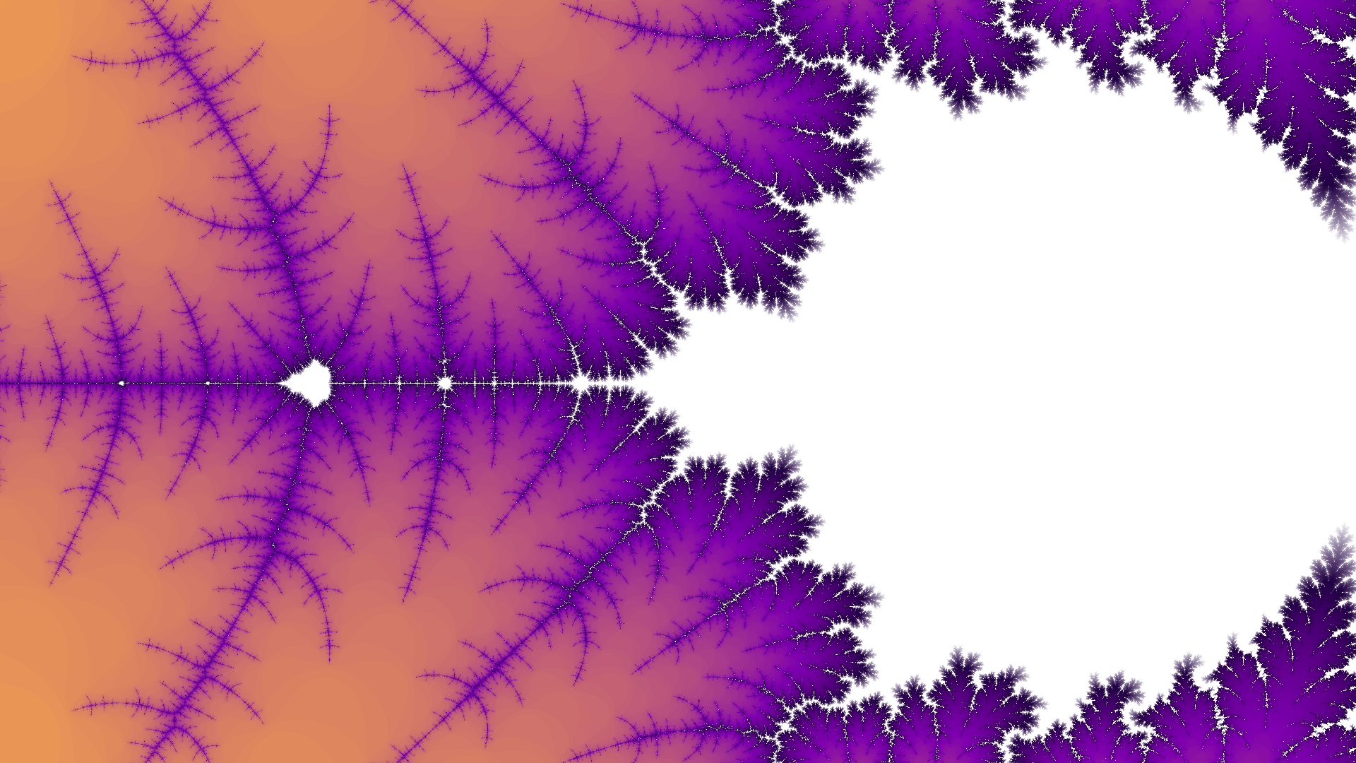



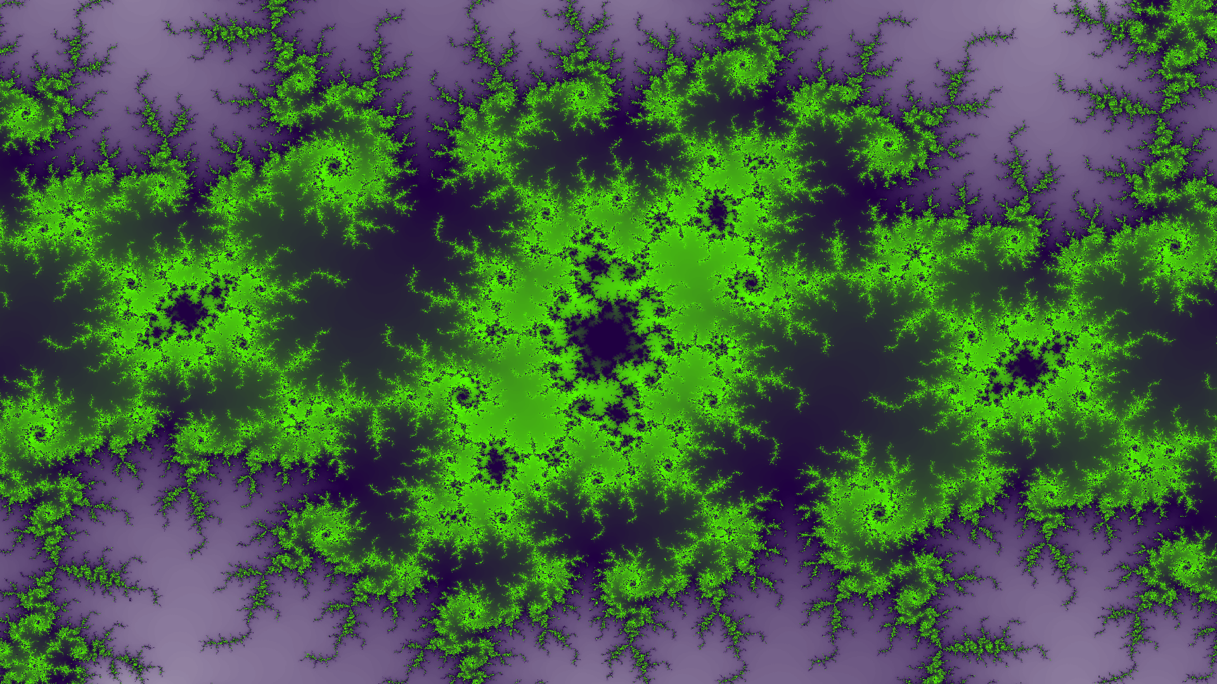

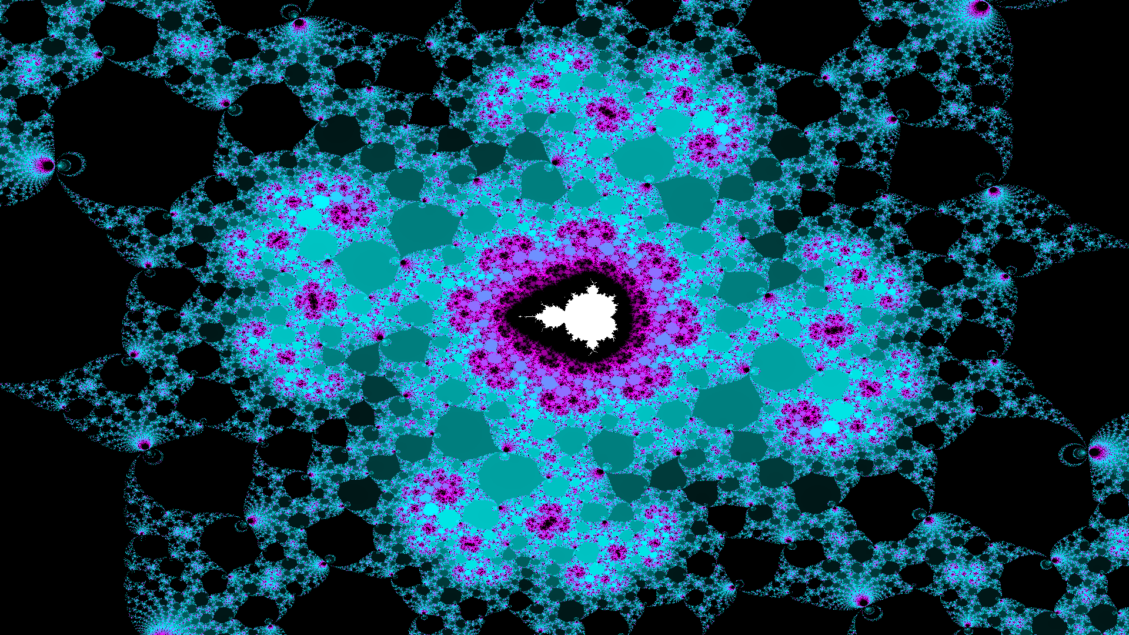

# References

|  |  |
| --- | --- |
| [1] | Xilinx, “Boards,” [Online]. Available: http://www.pynq.io/board.html. [Accessed 2 October 2018]. |
| [2] | Xilinx, “Xilinx/PYNQ,” [Online]. Available: https://github.com/Xilinx/PYNQ. [Accessed 2 October 2018]. |
| [3] | Xilinx, “PYNQ Introduction,” [Online]. Available: https://pynq.readthedocs.io/en/v2.3/. [Accessed 2 October 2018]. |
| [4] | Xilinx, “Getting Started,” [Online]. Available: https://pynq.readthedocs.io/en/v2.3/getting_started.html. [Accessed 2 October 2018]. |
| [5] | Digilent, “PYNQ-Z1: Python Productivity for Zynq-7000 ARM/FPGA SoC,” [Online]. Available: https://store.digilentinc.com/pynq-z1-python-productivity-for-zynq-7000-arm-fpga-soc/. [Accessed 2019 February 10]. |
| [6] | Google, “Dictionary,” [Online]. Available: https://www.google.com/search?q=Dictionary#dobs=fractal. [Accessed 17 February 2019]. |
| [7] | Wikipedia, “Sierpinski Triangle,” [Online]. Available: https://en.wikipedia.org/wiki/Sierpinski_triangle. [Accessed 17 February 2019]. |
| [8] | The University of British Columbia, “Fractal Dimension - Sierpinski Gasket,” [Online]. Available: http://www.math.ubc.ca/~cass/courses/m308-03b/projects-03b/skinner/ex-dimension-sierpinski_gasket.htm. [Accessed 17 February 2019]. |
| [9] | Wikipedia, “Iterated Function System,” [Online]. Available: https://en.wikipedia.org/wiki/Iterated_function_system. [Accessed 17 February 2019]. |
| [10] | M. McClure, “Construction Steps of Barnsley's Fern,” 28 August 2016. [Online]. Available: https://mathematica.stackexchange.com/questions/124919/construction-steps-of-barnsleys-fern. [Accessed 17 February 2019]. |
| [11] | Wikipedia, “Mandelbrot Set,” [Online]. Available: https://en.wikipedia.org/wiki/Mandelbrot_set. [Accessed 2 October 2018]. |
| [12] | P. Bourke, “The Mandelbrot at a Glance,” November 2002. [Online]. Available: http://paulbourke.net/fractals/mandelbrot/. [Accessed 17 February 2019]. |
| [13] | Order in Chaos, “Julia set,” [Online]. Available: https://orderinchoas.wordpress.com/tag/julia-set/. [Accessed 17 February 2019]. |
| [14] | Xilinx, “Python Environment,” [Online]. Available: https://pynq.readthedocs.io/en/v2.3/python_environment.html. [Accessed 2 October 2018]. |
| [15] | Tutorials Point, “Design Patterns - MVC Pattern,” [Online]. Available: https://www.tutorialspoint.com/design_pattern/mvc_pattern.htm. [Accessed 2 October 2018]. |
| [16] | Wikipedia, “VHDL,” [Online]. Available: https://en.wikipedia.org/wiki/VHDL. [Accessed 17 February 2019]. |
| [17] | Wikipedia, “High-level synthesis,” [Online]. Available: https://en.wikipedia.org/wiki/High-level_synthesis. [Accessed 17 February 2019]. |
| [18] | Xilinx, “Python productivity for Zynq (Pynq) Documentation,” 17 February 2017. [Online]. Available: https://media.readthedocs.org/pdf/pynq/v1.4/pynq.pdf. [Accessed 4 November 2018]. |
| [19] | Xilinx, “pragma HLS interface,” 20 August 2018. [Online]. Available: https://japan.xilinx.com/html_docs/xilinx2017_4/sdaccel_doc/jit1504034365862.html. [Accessed 4 November 2018]. |
| [20] | Xilinx, “DMA,” [Online]. Available: https://pynq.readthedocs.io/en/v2.3/pynq_libraries/dma.html. [Accessed 6 November 2018]. |
| [21] | Xilinx, “Video,” [Online]. Available: https://pynq.readthedocs.io/en/v2.3/pynq_libraries/video.html. [Accessed 6 November 2018]. |
| [22] | Xilinx, “PYNQ,” [Online]. Available: https://github.com/Xilinx/PYNQ. [Accessed 6 November 2018]. |
| [23] | Xilinx, “pragma HLS dataflow,” [Online]. Available: https://japan.xilinx.com/html_docs/xilinx2017_4/sdaccel_doc/sxx1504034358866.html. [Accessed 6 November 2018]. |
| [24] | Xilinx, “AXI Video Direct Memory Access v6.2,” 30 November 2016. [Online]. Available: https://www.xilinx.com/support/documentation/ip_documentation/axi_vdma/v6_2/pg020_axi_vdma.pdf. [Accessed 9 2 2019]. |
| [25] | Xilinx, “HLS Pragmas,” [Online]. Available: https://www.xilinx.com/html_docs/xilinx2018_3/sdaccel_doc/hls-pragmas-okr1504034364623.html#okr1504034364623. [Accessed 20 January 2019]. |
| [26] | Xilinx, “Vivado Design Suite User Guide: High-Level Synthesis (UG902),” May 30 2014. [Online]. Available: https://www.xilinx.com/support/documentation/sw_manuals/xilinx2014_1/ug902-vivado-high-level-synthesis.pdf. [Accessed 21 January 2019]. |